Applying for Access Link

APPLYING FOR ACCESS LINK SERVICES:

Telephone interviews are now being scheduled for those who want to be considered for full paratransit eligibility.

If you want to apply for services call 973-491-4224 and select option #1 to request a date to participate in a telephone interview. You will then be scheduled to speak with a representative from our statewide network of Assessment Agencies.

During your telephone interview, you will be asked about your disability or disabilities and the impact on your ability to use NJ TRANSIT’s local fixed-route system to travel. You will have the opportunity to provide examples of how and when you are prevented from using NJ TRANSIT’s fixed-route system to travel to or from your intended destinations. You will also need to provide medical verification of your disability or disabilities.

For more information about Access Link or the accessible services available on the Bus, Train and Light Rail you are encouraged to review the information provided under 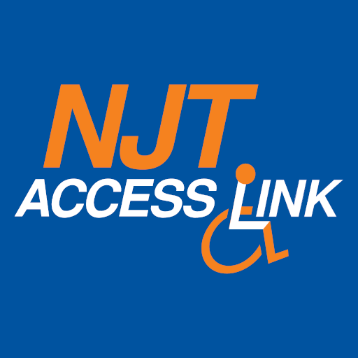ACCESSIBILITY at [www.njtransit.com](http://www.njtransit.com/).