**HIGHLAND HIGH SCHOOL**

**AIR FORCE**

**JUNIOR RESERVE OFFICER TRAINING CORPS**

(AFJROTC)



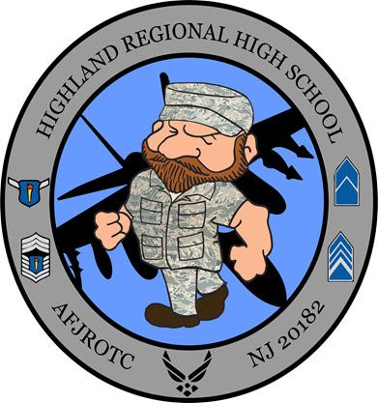

NJ-20182 Cadet Handbook

“Tartans”

Property of Cadet Revised August 2023

____________________

**TABLE OF CONTENTS**

Principal’s Welcome Letter to Cadets………………………………………………………………………………..6

Chapter 1 – Eligibility, Enrollment and Disenrollment………………………………………………………………6

Chapter 2 – History of AFJROTC Unit NJ20182  7

Chapter 3 – AFJROTC Mission, Purpose, Vision, Core Values ..………………………………………………... 8

Chapter 4 – Cadet Conduct….  9

Chapter 5 – AFJROTC Classroom Procedures 13

Chapter 6 – Government Property 15

Chapter 7 –Uniform Care and Inspection Guidelines 16

Chapter 8 – Cadet Promotion System 22

Chapter 9 – Community Service 24

Chapter 10 – Co-curricular Activities/Field Trips 25

Chapter 11 – Course Outline and Grading Policy 26

Chapter 12 – Social Media 29

Chapter 13 – Corps Position Selection/Job Descriptions………………………………………………...……… 30

Attachment 1 – Manning Document 33

Attachment 2 – Cadet Basic Knowledge.……………………...…………………...…………………………........34

Attachment 3 – How to Tie a Tie 36

Attachment 4 – Cadet Evaluation Report 37

Attachment 5 – Grading Rubrics ………………………...…………………...…………………………... 38

Attachment 6 – Daily Class Statements 44

Attachment 7 – Cadet Chain of Command 45

Attachment 8 – Cadet Contract and Application…..…………………………………………………….………….46

Attachment 9 - Added Information for Promotion Testing 50

Attachment 10 - Syllabus and Seven year Curriculum Plan 53

Attachment 11 - Unit Departure Form Template 58

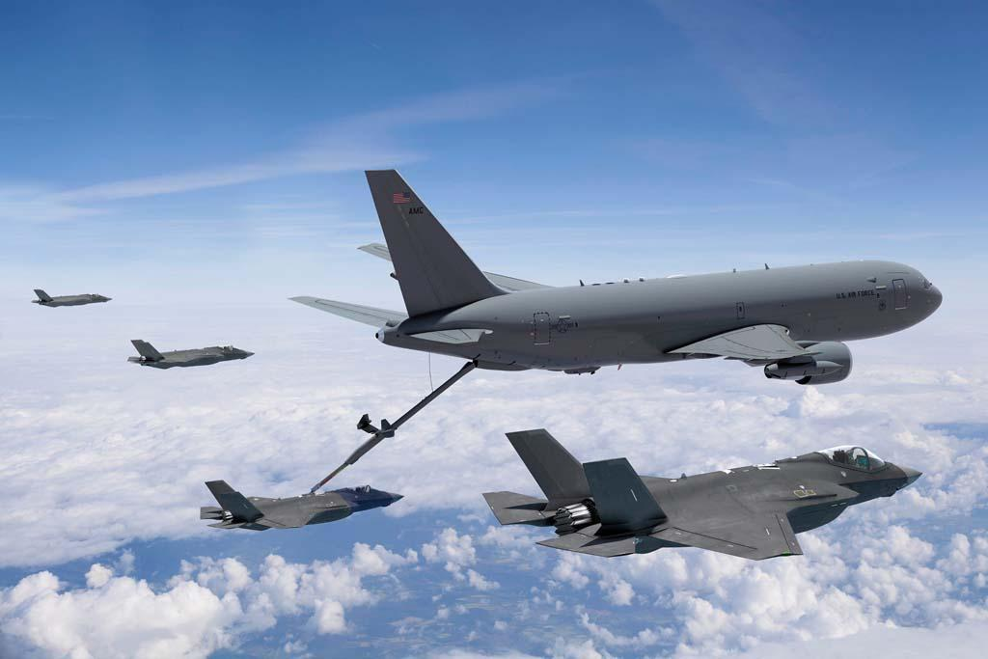

KC-46 Pegasus refueling F-35 Lightning II while wingmen provide cover.

Period:____ Flt/CC:____________

Flight:_____ Sq/CC:____________

Rank:_____ Flt Sgt:_____________

My Wingman:_________ 1st Sgt:____________

Mentor:_____

Mentee:_____

BLACK HORSE PIKE REGIONAL SCHOOL DISTRICT

**HIGHLAND REGIONAL HIGH SCHOOL**

450 Erial Road, Blackwood, New Jersey 08012

(856) 227-4100 Fax # (856) 227-3619

Principal: Mr. Ryan C. Varga

Assistant Principals: Mr. Beaver, Mrs. Dalessio, Mr. McEnnis, Ms. Steele, Mr. Strauss

August 15th 2023

Air Force JROTC Cadets

On behalf of the administration, faculty, staff, and the entire Tartan Territory, I would like to welcome you as a cadet to the Highland JROTC program. This program reflects important core values and principles that will guide each of you with future endeavors. We emphasize the characteristic traits of being a positive and productive member of the Highland community. Our Highland JROTC program focuses and supports these characteristics by emphasizing their core values including Integrity First, Service Before Self, and Excellence in All We Do. It is our hope that all of our students set goals to meet the high standards that propel them for success.

I have always enjoyed and supported a strong partnership with the JROTC instructors and cadets to build service-focused leaders that add to our whole school community. Through your classes and opportunities to experience activities in the field, you have decided to commit to building a strong foundation on which to solidify your future. I encourage you to take advantage of every opportunity to grow as a student leader. We are here to support and encourage you throughout your high school career.

The sky's the limit and I would like to end with a quote from one of my favorite athletes:

“There may be people that have more talent than you, but there’s no excuse for anyone to work harder than you do.” - Derek Jeter

Go Tartans!!!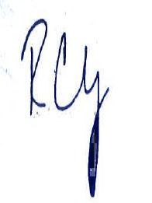

Ryan C. Varga

Principal

Highland Regional High School

@HighlandVarga

856-227-4100 Ext 4014

Wingmen, Leaders, Warriors

# CHAPTER 1 – ELIGIBILITY, ENROLLMENT AND DISENROLLMENT

1. **Eligible Students.** All Black Horse Pike Regional School District students, enrolled in a regular course of instruction and physically able to participate in AFJROTC activities may join AFJROTC. All AFJROTC students must be enrolled ***voluntarily*** and participate in the full program to include taking AFJROTC academic courses, participate in the cadet corps and wellness program, and wear the prescribed uniform on designated days.
2. Only high school students in the grade of 9-12, may enroll in AFJROTC. **Cadets enrolled in AFJROTC do not incur any military commitment. AFJROTC is a citizenship program and not a recruiting program.**
3. **Disenrollment.** AFJROTC students may be dis-enrolled at any time during the academic year with proper cause. A student may be dis-enrolled for:
   1. Failure to maintain acceptable standards (including uniform wear and grooming).
   2. Inaptitude or indifference to training.
   3. Disciplinary reasons (including actions warranting OSS and ISS)
   4. Any other reason deemed appropriate by the AFJROTC SASI and the principal to maintain good order and discipline of the corps, such as: fighting (filming or encouraging as well) bullying, violating student handbook, cadet guide, etc. .
   5. A student who fails the AFJROTC course for the year may only re-enroll at the discretion of the SASI (that student will re-enroll in the same level as the one they failed).
4. Other Considerations.
   1. Special needs and handicapped students may participate in AFJROTC with the concurrence of the SASI and the principal. However, AFJROTC should not have a disproportionate number of any special groups of students as compared to the remainder of the student body.
   2. Cadets wishing to participate in after school co-curricular AFJROTC activities may do so at the discretion of the SASI/ASI. **Academic performance may cause SASI to restrict participation**.
   3. Only students currently enrolled in the full AFJROTC program, or in Reserve status, may be issued uniforms.
   4. While AFJROTC instills self-discipline, it is not a remedy for chronic student disciplinary problems. Cadets unwilling to conform to standards must be removed.
5. Reserve Cadets. A student who has been a cadet for at least one academic year, who completed the entire AFJROTC Academic Program and cannot participate in the AFJROTC academic program for that particular year, may be designated as a Reserve Cadet. Reserve Cadets may participate in all AFJROTC activities (community service, drill team, color guard, etc.). Time in reserve status does not count towards the Certificate of Completion. Reserve Cadets may retain their uniform for the entire academic year and must maintain grooming/dress standards while in uniform.

# CHAPTER 2 – HISTORY OF AFJROTC UNIT NJ-20182

Unit activation of Highland High School, Air Force JROTC, NJ-20182, began in the school year 2018-2019. NJ stands for New Jersey, 2018 represents the year that the unit was established, and the number 2 stands for the second unit to be established in New Jersey that year.

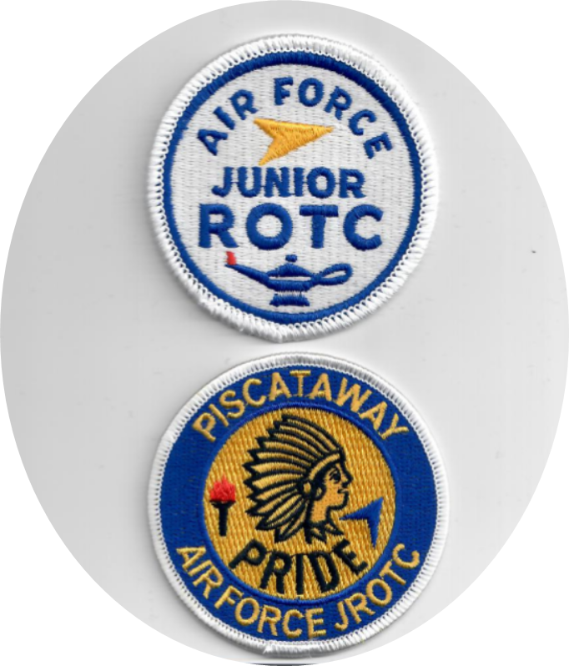

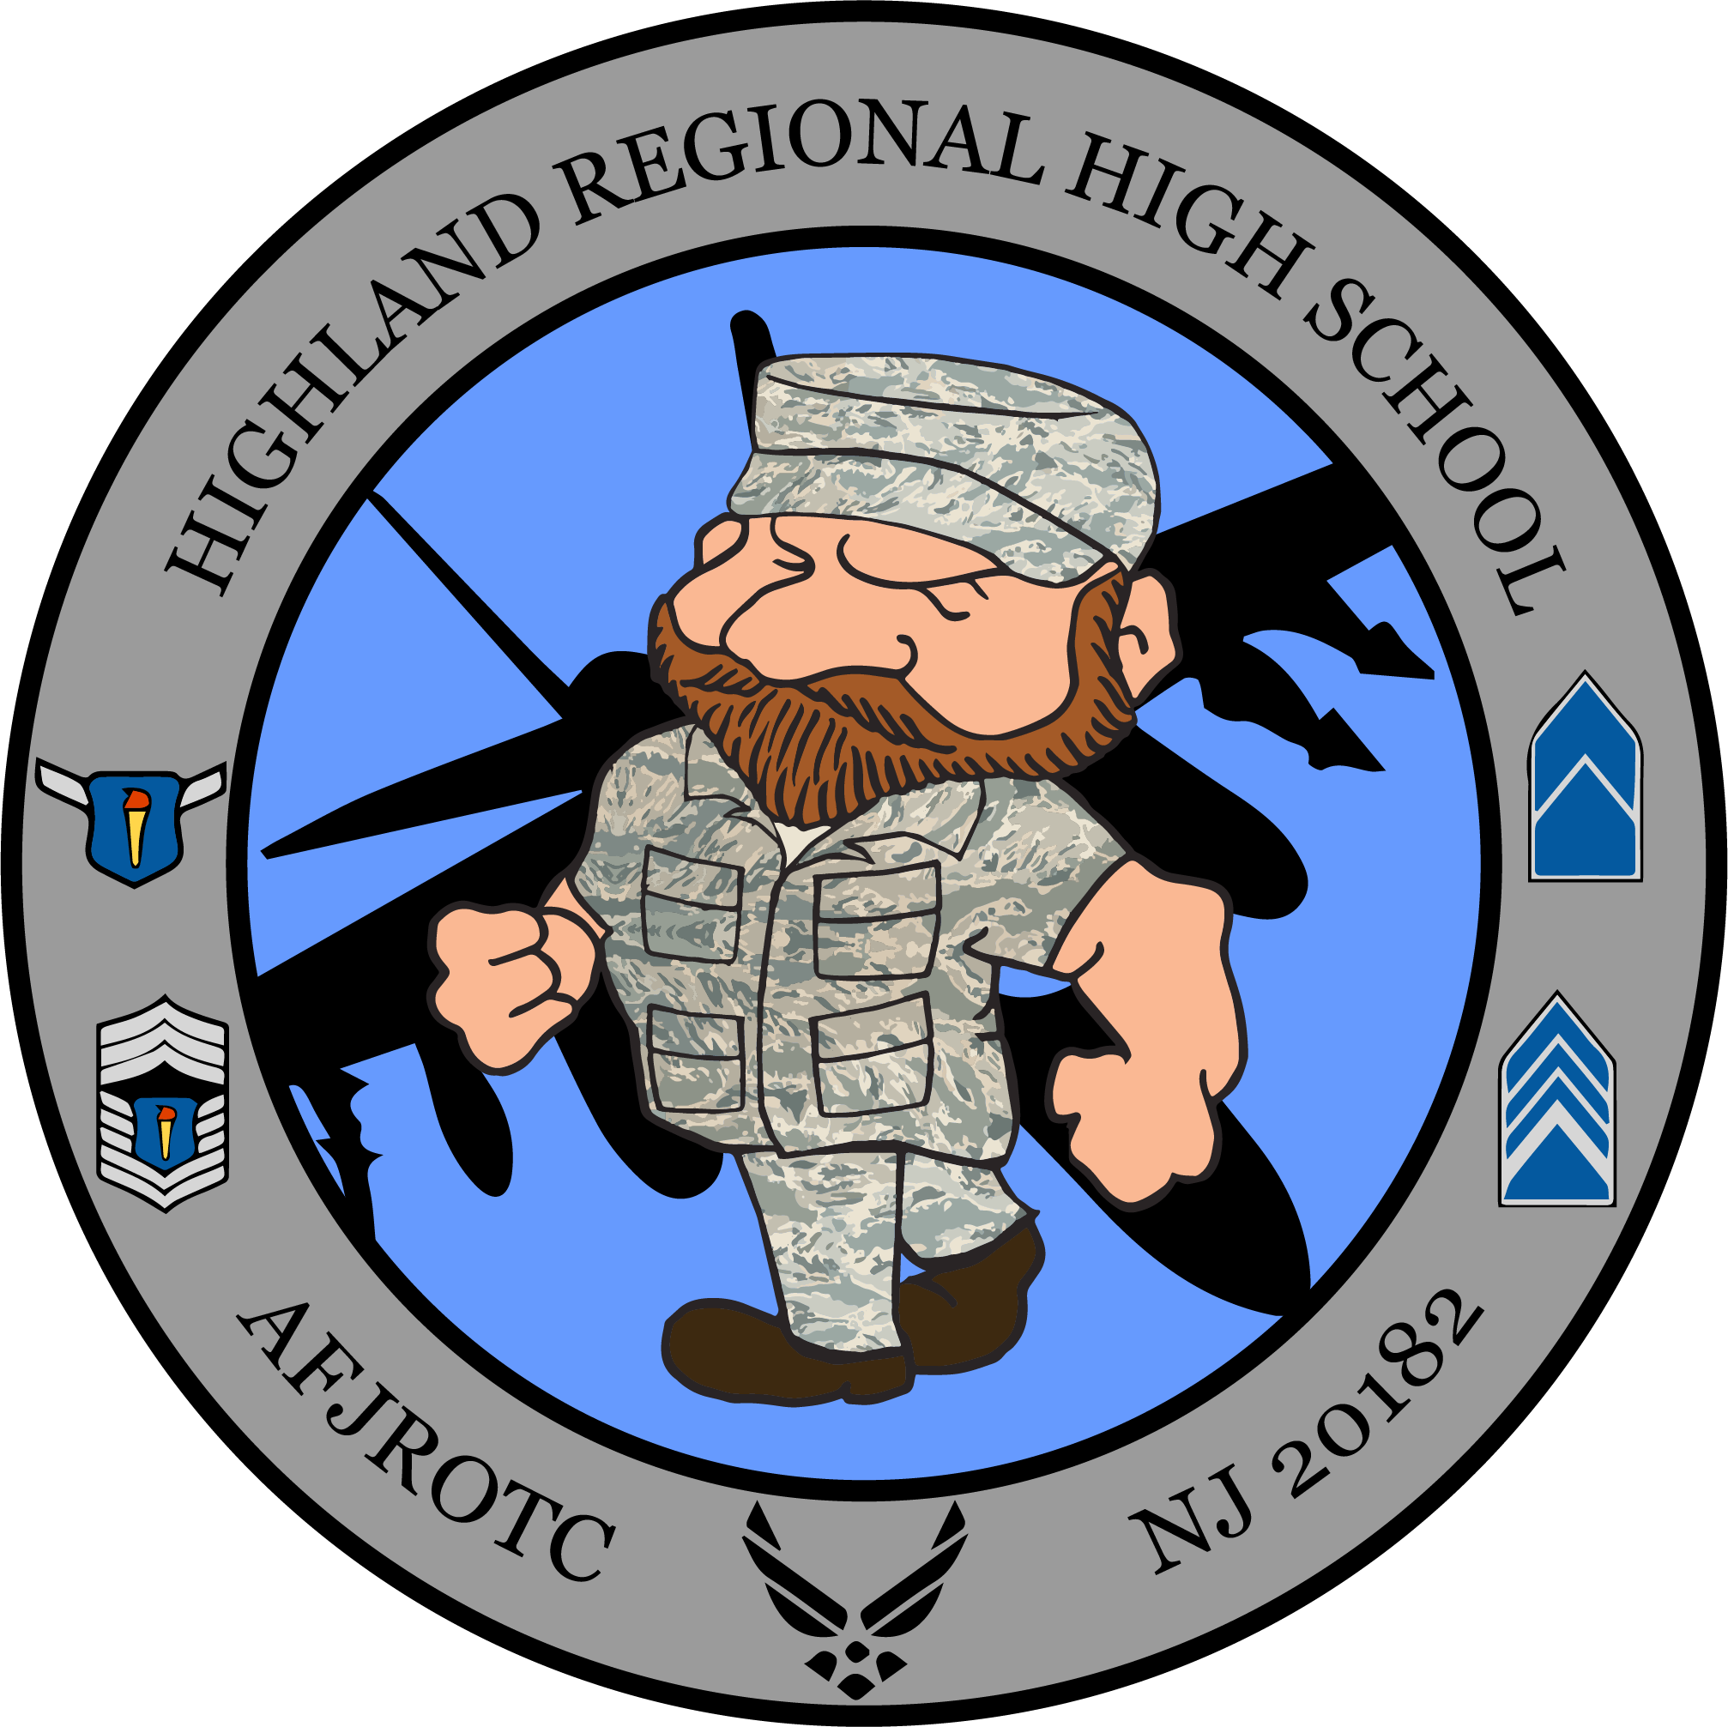

**CHAPTER 3 – AFJROTC, MISSION, PURPOSE, VISION, CORE VALUES**

Cadets are required to know the mission statement, core values, and honor code verbatim and may be tested on them at any time.

**Our Mission**

“Develop citizens of character dedicated to serving their nation and community.” (**Memorization Item**)

**Our Core Values**

Integrity first, Service before self, and Excellence in all we do. (**Memorization Item**)

**Our Purpose**

Instill in students the value of citizenship, service to the United States, personal responsibility, character, and a sense of accomplishment. To make the greatest positive impact in the lives of our cadets as possible. This is perfectly encapsulated in our motto: “Building Better Citizens for America.”

**Our Vision Statement**

Air Force Junior ROTC (AFJROTC) will provide a quality citizenship, character, and leadership development program, while fostering enduring partnerships and relationships with high schools, educational institutions, and communities that help meet our citizen development mission.

**Air Force Mission**

The mission of the United States Air Force is to fly, fight and win—in air, space cyberspace and through time.**To fly, fight, and win…airpower anytime, anywhere.**

**Open Door Policy**

Instructors are faculty members and maintain teacher responsibilities. Cadets may seek ASI/SASI guidance at any time but should attempt to use the chain of command when practical.

**CHAPTER 4 – CADET CONDUCT**

1. **Attitude -** is a state of mind. It may be positive or it may be negative. Your attitude affects the success or failure of most of your activities. Your attitude reflects your personal philosophy of life as it is shown by your actions. Your attitude is the frame of mind in which you view yourself, your work, and others.
   1. The Air Force Junior ROTC program is built around the individual. Every person in the program is a key to the success of his or her unit, and, therefore, is a key to the success of the entire unit. If you have a good attitude (that is, you will work to your potential while actively participating in the program), you will be doing your share in the cooperative operation of Air Force Junior ROTC.
   2. Cadets should work up to their potential through active participation in AFJROTC activities. Under all circumstances, cadets should be courteous and respectful and seek responsibility. Cadets are expected to be considerate, mature young men and women. Cadets are responsible for their own attitude in any given situation and will not blame their attitude on someone else or circumstance beyond their control.
   3. Cadets are expected to **FUNCTION WITH MINIMUM SUPERVISION** and to take the initiative in solving problems using available reference material and the chain of command. **This is to reinforce a culture of taking action to solve any encountered problems without having to wait on direct orders.**
   4. Cadets are required to follow instructions by NCO/Officers in matters relating to AFJROTC.
2. **Discipline -** refers to instruction aimed at guiding a person toward proper conduct or action, or to the orderly conduct and action that result from such training. In much simpler terms, military discipline is that mental attitude and state of training that renders innate obedience and proper conduct under all conditions.
3. **Respect -** Respect for authority and discipline also reinforce one another. But you must first acquire discipline. Self-discipline involves full and voluntary acceptance of authority. Understanding that some things—both pleasant and unpleasant—simply must be done and that there must also be people to ensure that those things get done will help you to respect authority.
4. **Integrity -** The term ethics suggests to some people a very personal, individual standard or philosophy. However, the basic principles of integrity and conduct are guided by a sense of right and wrong. A cadet’s sense of right and wrong must be so strong that his or her behavior and motives are above suspicion. Integrity is a firm adherence to a code of especially strong moral values. In other words, integrity is honesty.
5. **Ethics -** as the rules of conduct that people should follow. Ethics deal with the struggle between good and evil—judging whether something we do, say, choose, or think is right or wrong. Some basic **AFJROTC** rules of ethics are:
   1. Be honest.
   2. Keep promises.
   3. Obey and be loyal to proper authorities.
   4. Be courageous.
   5. Grow in knowledge.
   6. Be willing to work.
   7. Be moderate (don’t do anything to excess).
   8. Maintain and enhance your health.
   9. Don’t harm people.
6. **United States Air Force Core Values**.
   1. **Integrity First** - Integrity is a character trait. It is the willingness to do what is right even when no one is looking. It is the moral compass—the inner voice, the voice of self-control, the basis for the trust needed in today’s military. Integrity is the ability to hold together and properly regulate all elements of one’s personality. People of integrity, for example, are capable of acting on conviction, or their strong beliefs. They can control their impulses and appetites.
   2. **Service before Self** - This statement tells us that professional duties take precedence over personal desires.
   3. **Excellence in all we do** - This core value states that for any undertaking we choose, we should give it our best effort; whether you are doing your homework, playing on the school baseball team, or wearing the uniform, anything less should be unacceptable. This expression also directs us to develop a passion for continuous improvement that will propel us into a long-term, upward spiral of accomplishment and performance.
7. **Cadet Roles and Responsibilities**.
   1. Cadets are required to follow regulations and instructions issued by the United States Air Force, Highland High School, the AFJROTC Instructors, cadet staff and commissioned/ non-commissioned officers.
   2. The task for you at each level is to learn the job, do the job as well as you can, prove you are ready for the next level of responsibility, set the best example and develop into a good leader by showing an honest understanding and respect for authority.
   3. Cadets are chosen for leadership positions based on demonstrated performance, job knowledge, leadership potential and potential to take on more responsibility.
   4. Cadet leaders are entitled to respect and courtesy from subordinates and junior ranking cadets will show respect to higher ranking cadets.
   5. Cadet leaders are required to provide a proper example at all times and for maintaining good order and discipline. Whenever a cadet leader is absent, he/she will notify the next in command to take charge and explain his/her specific duties.
   6. Cadet leaders are authorized to give appropriate and reasonable orders to cadets under their supervision, but have no authority to excuse them from scheduled formations or classes or to change or modify existing orders without specific orders, instructions and/or approval from the SASI/ASI. Cadets will not abuse their rank or position.
8. **Titles of Address**—Civilians are addressed by the title Mr., Mrs., Ms., or Miss, Dr. etc. Military persons, including instructors, will always be addressed by their rank and last name or sir/ma’am as appropriate. Cadets should be addressed by their cadet rank and last name (always use the word ***cadet*** as to not confuse with active duty grades) or, it is always acceptable to address a cadet by the title of Mr. or Miss and their last name. Cadet Officers may also be addressed as Sir or Ma’am.
9. **Saluting**—The hand salute is an established custom of exchanging a courteous greeting between individuals in military uniform. The salute is a greeting, a custom, and a mandatory courtesy that is exchanged outside when in uniform. Salutes are not required indoors, except for formal reporting, training, and those areas designated for saluting by the SASI/ASI. Salutes are not required when cadets are not in uniform. Saluting in accordance with USAF guidance/norms is a requirement of AFJROTC.
   1. When to Salute—Active Duty, Retired and Cadet Officers will be saluted outside in uniform on and off campus.
   2. The salute will be rendered while outside in uniform during the raising or lowering/parade of the US Flag, during the Pledge of Allegiance, and playing of the “National Anthem” or “To the Colors.”
   3. Pledge of Allegiance at School—when at school, in civilian clothing, during the pledge of allegiance, cadets will stand at attention, place their hand over their heart and recite the pledge. In uniform, cadets will stand at attention. Outdoors in uniform cadets will salute.
   4. **JROTC CADETS ARE EXPECTED TO COMPLY WITH US FLAG CODE AND USAF REGULATIONS ON HONORS TO THE FLAG, NATIONAL ANTHEM, AND PLEDGE OF ALLEGIANCE AS A CONDITION OF CONTINUED ENROLLMENT IN THE COURSE**.

1. **Academic Standards**—Your hard work, sincere interest, effort, and positive attitude are keys to your success. Initiative, enthusiasm, and cooperation will result in your development and improvement academically. You are expected to do your homework, turn in your work and pass your classes. The SASI and ASI will monitor your academic progress. Academic eligibility is a requirement for many of our activities and field trips. Promotion is also based on academics. **A CONTINUED LACK OF ACADEMIC PERFORMANCE MAY BE CONSIDERATION FOR REMOVAL FROM THE AFJROTC PROGRAM. THE SASI AND ASI ARE AVAILABLE AT ANY TIME TO ASSIST YOU IN REACHING YOUR OBJECTIVES AND GOALS.**
2. **Standards**—After joining the cadet corps, new cadets should meet established standards within the first week of school. **If a cadet cannot or will not meet the standards, the individual may be dismissed from the corps.** Each cadet is expected to set an example for other cadets, as well as other students. This means that as soon as AFJROTC standards are known and understood, each cadet should meet or exceed them.
3. **Competition**—Healthy competition in academics, wellness and other activities is a vital part of the promotion and awards system. Keeping this in mind, aggressive and physically threatening behavior will not be tolerated and will be dealt with within the discipline guidelines of the unit and school (found in the Code of Conduct and school handbook).
4. **Public Display of Affection (PDA)** — **PDA is prohibited by and between all cadets in uniform, on campus or off campus**. Out of uniform, cadets will comply with school policy but are expected to maintain behavior appropriate for the environment/situation as determined by the SASI/ASI during JROTC activities. No PDA in the JROTC environment.
5. **Inappropriate Behavior**—Inappropriate behavior, in or out of uniform, is prohibited while participating in AFJROTC. As stated previously, **this type behavior will not be tolerated** and will be dealt with within the discipline guidelines of the unit and school.  **Inappropriate behavior may be grounds for removal from AFJROTC**. These behaviors include, but are not limited to:
   1. Using alcohol, drugs, tobacco, vaping,
   2. Horseplay, fighting (filming, encouraging or spectating), physical attacks
   3. Derogatory remarks (racial/ethnic slurs, slander/libel), disrespect, verbal threats.
   4. Insubordination (disobedient to authority), insolence
   5. Inappropriate use of Social Media/photography/recording
   6. Violations of District/School policies
6. **Prohibition on Physical Discipline and Hazing**. Any form of hazing, whether verbal or physical, will not be tolerated within any AFJROTC unit or activity. In addition, requiring cadets, individually or as a group, to perform any physical action as a reprimand, punishment, or for failure to perform will also not be tolerated. Cadets will not condone or encourage any type of hazing or initiation rituals.
   1. Examples of prohibited physical activities include, but are not limited to: push- ups, running laps, or any inappropriate physical contact such as shoving, pulling or grabbing.
   2. Any form of verbal abuse, teasing, public rebuke or any attempt to otherwise humiliate a cadet is prohibited.
   3. This prohibition is applicable to all AFJROTC unit activities, and includes instructors, cadets and any personnel involved with or participating in an AFJROTC unit or activity.
   4. Unauthorized Clubs. No unit may encourage, facilitate, or otherwise condone secret societies or private clubs as part of the AFJROTC program
7. **JROTC CADETS ARE EXPECTED TO COMPLY WITH US FLAG CODE AND USAF REGULATIONS ON HONORS TO THE FLAG, NATIONAL ANTHEM, AND PLEDGE OF ALLEGIANCE AS A CONDITION OF CONTINUED ENROLLMENT IN THE COURSE**.

**CADET RESPONSIBILITY**: Each cadet must agree to abide by the rules and instructions of this AFJROTC unit and accept responsibility for the proper care and maintenance of their uniform, textbooks, and school/AFJROTC equipment before they can become a member of the Cadet Corps. **This acceptance of responsibility is signified with the signing of the cadet contract by the cadet and parent/guardian (contract located at end of guide and posted to all cadet classrooms).**

# 

**CHAPTER 5 - AFJROTC CLASSROOM PROCEDURES**

1. Prior to class:
   1. **Classroom Entrance** — Cadets will enter the classroom, **greet the instructor and sit in their assigned seat with book bags placed behind or to the right of the desk**. Expectation is for cadets to be seated at desks at the bell. Class materials will be on the desk.  **Being on time is a graded item.**
   2. **Call Up** — After the bell rings, the flight commander/ sergeant will call the room to attention, take attendance, read the announcements and give any direction to get the class started. If both are not present, the highest ranking cadet will take initiative to do it themselves or delegate.**The Air Force Song will be sung every Wednesday after attendance report**.
   3. **Tardiness** — Cadets arriving late will comply with student handbook procedures. Tardiness is a

gradable item.

1. **The flight commander/sergeant, when appropriate, should notify the instructor when there is 3 minutes remaining in the period.** At this time, the flight commander/sergeant will lead the class in preparing for dismissal, straightening the room, returning books to the shelves, etc.
2. Conducting class in AFJROTC—All classes will be conducted in a military manner. The following classroom rules of conduct apply. Following classroom rules will be incorporated in your overall grade for the course. Cadet leaders will mentor subordinates using “Cadet Evaluation Report” and will provide that information to instructor staff for consideration in grading rubric. Cadets **WILL NOT:**
   1. Leave the classroom after entering without the instructor's permission.
   2. **Leave their seat without permission.**
   3. Talk when the instructor is speaking or someone else has the floor.
   4. **Sit on desktops,** step or jump through desks, tilt chairs backward or put feet on tables or chairs.
   5. Throw anything in the classroom.
   6. Write on or deface tables, chairs, walls, books, etc.
   7. **Eat, drink, or chew gum in the classroom, unless given permission. (Only water is permitted)**
   8. Disturb pictures or bulletin board items.
   9. Read or work on material that does not apply to AFJROTC without permission from the instructor.
   10. Sit in any seat other than your assigned seat, unless instructed otherwise.
   11. Make loud noises or participate in horseplay in the classroom.
   12. **Throw trash on the floor.**
   13. Sleep in class. If a cadet feels drowsy, they are expected to leave their seat and stand quietly in the back of the room. Once they feel refreshed they may return to their seat.
   14. Use/have powered on electronic devices without instructor permission.
   15. Complete homework during instruction.
3. **Academic Work**—The AFJROTC curriculum is presented by the instructors in a variety of ways including teaching lectures, guided discussions, interactive activities and games, demonstration/performance method, etc. Cadets will be called upon for discussions, assigned tasks and written work, and at times broken into smaller groups for dynamic learning. At all times, cadets are expected to fully participate in classroom activities. Cadet participation in discussions is expected within the context of academic freedom. However, the SASI/ASI may terminate a discussion at his/her discretion if in their judgment it becomes contrary/irrelevant to the aims of the JROTC curriculum. For all written assignments, **cadets will be required to label their work in the format at the top of the next page:**

**Header format for all work:**

**First Line: Cadet Rank, Last Name, First Initial Second Line: Period**

**Third Line: Military Date Format**



1. **Homework** —Homework will be published in the weekly overview or assigned separately. Homework is due at the beginning of class and will be considered late after class opening**. Each day an assignment is late will deduct 10 pts from the grade.**
2. Instructor Office Entrance Procedures. Cadets are welcome to enter the instructor office when needed and permission is granted. If the door is closed, knock once and wait to be acknowledged. Cadets may not touch anything on the instructors’ desks
3. Supply Room—Logistics (LG) staff are the only authorized personnel to issue/remove items from the supply room. Every cadet is responsible for keeping the area tidy. If no cadet from LG is available, do what was instructed and immediately notify the OIC of LG and inform them of the situation at hand. No food or drinks are allowed in the supply room without permission.

**CHAPTER 6 - GOVERNMENT PROPERTY**

1. **Texts and Reference Books**—AFJROTC texts are available to each cadet in addition to posting on school selected web portals. However, cadets may check the books out using a hand receipt. Any texts, books or other government property lost, damaged, or destroyed due to improper handling will be paid for by the individual cadet.
2. **Uniform Initial Issue**—within the first weeks of school, parent’s acceptance of responsibility, and cadets meeting established standards, each cadet will be issued an AFJROTC uniform. Initial issue will include the following items:

a. Shoes (1 pair)

Pants (1 pair)

Short-sleeve Shirt (1)

Service Coat (1)

Lightweight Jacket (1)

Socks (1 pair)

Flight Cap (1)

V-neck T-shirt (1)* Tie or Neck Tab (1)

Belt and Buckle (1 each) Blue Name Tag for shirt (1)

Silver Name Tag: Service Coat(1) Air Force PT Shirt (1)

Air Force PT Shorts (1)

Air Force Sweatshirt (1)

All Weather Coat (1)

1. **Any items that need alterations will be taken by the instructors for alterations covered at government expense.**
2. **Responsibilities**—Cadets will care for and properly maintain uniforms, equipment, textbooks and other AFJROTC or school facilities provided for their use. The cadet and his/her parent or guardian must understand that the equipment must be returned in good condition and by the specified due date. Payment for loss, damage, or cleaning of any item will be at the current market price.

## Supply Discipline:

* 1. Purpose—The uniform represents our nation and its highest ideals. Persons wearing the uniform must maintain this respect by ensuring his/her uniform is always correct and in good condition.
  2. Maintenance:
     1. Uniform items that become unserviceable (i.e., torn, frayed, stained, buttons missing, etc.) must be brought in for replacement as soon as the condition is discovered.
     2. If a uniform item no longer fits, the cadet must bring it in for replacement as soon as possible.
     3. Cadets will not have items of issue altered by parents or tailors in any manner, without the permission of the SASI/ASI. Alterations will be made in accordance with Air Force standards.
     4. All garments are to be marked with a unique number and recorded on hand receipts.

1. **Uniform Turn-in**—When a cadet graduates, drops, dis-enrolls, or leaves the program or school for any reason, he/she is required to turn in all issued uniform items. **Uniforms are issued in a clean condition; therefore, they must be turned in clean (cleaners bag and receipt required)**. Uniforms not turned in completely/dry cleaned will result in a school fine levy. Ties, covers, coats and jackets, blue shirts, and pants must be dry-cleaned; socks, V-necks, PT Shirt, and PT Shorts may be washed. Completion certificates, awards, and other items may be withheld until uniform items are turned in or paid for.

**CHAPTER 7 – UNIFORM CARE AND INSPECTION GUIDELINES**

1. Air Force Junior ROTC cadets generally wear the same uniforms worn by active duty personnel with the exception of special JROTC rank and patches. “Cadets are expected to honor the uniform—to wear it properly and with pride.” The wear of the Air Force uniform unites with and identifies you as an associate member of the finest Air Force in the world. The governing directives for uniform wear are Air Force Instruction (AFI) 36-2903, *Dress and Personal Appearance of Air Force Personnel;* Air Force Junior ROTC Instruction 36-2001, and the guidelines published in this Cadet Handbook. These directives provide information on grooming standards and uniform wear standards. **Until the uniform is issued to a new cadet, cadets will be issued a unit polo shirt that must be worn with jeans/slacks and sneakers or shoes on uniform inspection days.** This will be the uniform until a cadet receives their military uniform issue. Along with wearing this ensemble **new cadets will be inspected on grooming standards as well. The full list of inspectable areas for new cadets is below. We will use the same grading scale listed on pages 20 - 21 for each of the 8 areas.**
2. Comply with haircut standards
3. Comply with shaving standards
4. Comply with piercing and bracelet standards
5. Comply with nail polish and nail standards (females only)
6. Comply with the standard of presenting a neat appearance
7. Wear the new cadet polo shirt
8. Wear sneakers or shoes; **NO SLIDES ON UNIFORM DAY.**
9. **Wear pants/jeans DO NOT wear sweats or ripped jeans on inspection day.** (Save sweats for Wellness day.)

**NOTE:** *Failure to comply with the above directions will result in applicable point deductions during inspections*. The above **standards for non-uniform inspection are meant to**

**instill a sense of pride in how one presents one’s self,** especially during inspection time.

1. The proper wearing of the uniform should be a matter of personal pride. Knowing that being properly groomed and your uniform is clean, pressed, neat, and conforming to instructions gives confidence and projects a positive image. Achieving this requires acceptance of personal responsibility to pay careful attention to detail when setting up your uniform, as well as cleaning, caring and storage of the uniform. At no time do we bring discredit to the Air Force uniform by wearing it improperly.
2. Occasions for wearing. Cadets will receive instruction on the proper wear of all uniforms. It is the responsibility of each cadet to ensure his or her uniform is cared for and worn when required. The wear of the AFJROTC uniform other than the occasions designated is strictly prohibited without prior approval of the SASI or ASI. On uniform inspection days cadets are expected to adhere to the following.
   1. Wear the complete uniform in the proper manner and be properly groomed from the time you depart your home until you return home.
   2. If you participate in an extracurricular activity after school such as band, athletics, cheer, etc., that requires activities that may soil the uniform, you may elect to bring other clothes to change into on the last period of the day or after school.
   3. At no time will a uniform item be worn with non-uniform clothing.
   4. Civilian attire such as coats, sweaters, hoodies, sweatshirts, or windbreakers will NOT be worn with the uniform at any time. **WEARING A GARMENT OVER THE UNIFORM IS CONSIDERED A NON WEAR FOR THE DAY.**
   5. Failure to wear the uniform properly and/or when required **WILL** result in loss of credit and or disciplinary actions. **Three non-uniform wears in one marking period will result in a failing grade in the course for the marking period regardless of the grades received in other program components. However, as a way to incentivize subsequent proper uniform wear, an instructor will do a grade change at the end of the marking period following the failure; if the cadet does not have more than one missed uniform wear by the end of that marking period**. **Continued failure to wear uniform will result in administrative action (letter of counseling etc.) and possible removal per Chapter 1, para. 3A**. Should you have any questions concerning uniform inspection or wear requirements contact the SASI/ASI. Proper uniform wear is a teaching tool to ensure cadets can present themselves in attire similar to the professional world.
3. AFJROTC Cadets do not ***“have”*** to wear the great USAF uniform…they ***“get”*** the honor of wearing the uniform and are expected to wear it proudly. The AFJROTC uniform must be worn once per week as directed by the Air Force. It is ***your*** responsibility to comply with this contract.
4. Wearing once per week is defined as wearing the uniform to school **ALL DAY**. It is understood that under special circumstances, it may be necessary for you to change out of your uniform during the school day. Examples of this include but are not limited to athletic or PE classes, ceramics, or cooking classes, or other groups that might require you to wear another school uniform. In these cases, you are required to wear the JROTC uniform up until the time you may be required to change out of your uniform. You are then required to change back into your uniform after that class is over **(UNLESS THAT CLASS TOOK PLACE IN THE LAST BLOCK)** If you fail to change back into your uniform as required per the above policy, you may be given a uniform grade of zero for the day. If your first period class is gym or activity that could soil the uniform, you may carry uniform to school and change after first block activity is over
5. **Uniform Wear Make Ups**—Cadets will receive a weekly uniform grade, which will be a maximum of 100 points. Uniform Inspections are normally Wednesdays. The actual grade a cadet receives will be determined by a personal inspection in which each weighted item carries a point value. If a cadet is not in uniform on the assigned day, a grade of MISSING will be entered into the grade book. If the cadet is excused for the day no penalty is assessed. If the non-wear is not excused it will incur a 25 point penalty.  **If a cadet is making up a uniform wear day, they must wear the full uniform on Thursday, regardless if they have the JROTC class.** **It is the cadet’s responsibility to go to the JROTC classroom to be inspected by the SASI/ASI**. If a cadet knows in advance that they will be absent on the uniform wear day, they are responsible to wear the uniform after the absence and will receive a full grade based on a personal inspection. If the cadet misses uniform wear on Wednesday and Thursday they must wear on Friday but will incur an additional 25 point penalty.  **Uniform wear is not an excuse not to change for AFJROTC PT or gym class.**
6. Major uniform or cadet grooming violations that are due to direct refusal by the cadet to correct ***may*** result in the cadet being required to change out of the uniform into normal school clothes. This may include but not be limited to cases of extreme out-of-standards appearance to include hair, facial hair, white socks, civilian items worn with the uniform, etc. While this may seem to place an unfair burden on the cadets, it is important to remember that cadets wear the same uniform as active duty military members and will not be allowed to show disrespect to the uniform or become an embarrassment to the unit. This requirement may only be imposed by the instructors.
7. **Care of the Uniform**. All uniform items issued must be cared for and maintained by the cadet to whom it was issued. Uniforms should be dry-cleaned frequently but only as necessary to maintain appearance as dry-cleaning it every week will wear the uniform down and is an unnecessary cost of money. The best way to save on cleaning costs is to protect the uniform from dirt and wrinkling: don’t sit or lay on the floor, eat and drink carefully, don’t perform PT in blue uniform, hang items up carefully when not in use. Shirts should be cleaned every week, but laundering at home is acceptable with ironing to remove wrinkles.
8. **Your uniform should be clean every week prior to wearing it.** General care includes washing the uniform, taking care to not soil or stain it in any manner, and ensuring it is lint, dust and dirt free. You should hang your uniform appropriately…*DO NOT* stuff it in your backpack, cram it in your locker, or place it on your floor or in your closet. If at any time a uniform item becomes unserviceable, you must attempt to fix it or bring it to the ASI’s attention. If a button comes off, ask your family to sew it back on. Care of uniform items and other tips are described below. Always read the care labels of all items as well.
   1. You may wash the short sleeve blue shirt in a washing machine, dry it in a dryer and iron it to ensure it is wrinkle free.
   2. The pants/slacks/skirt, coats and jacket, flight caps, ties and neck tabs **MUST** be dry cleaned. These items may also be ironed on a low-heat setting. Please place a handkerchief between the iron and the fabric to avoid destroying the fabric.
   3. ***DO NOT***leave the necktie in a tight knot. Untie and retie the necktie with each wear.
   4. ***DO* place your name inside your flight cap…that way, when you lose it, we’ll know whose it is.**
   5. The service dress coat is “dry-clean **only”** and will ***never*** be placed in a washing machine or dryer…you will ruin it. Since the service dress coat is only worn occasionally, the recommendation is to take it to the dry cleaners a couple of times each semester.
   6. Keep a lint brush at home and use it before you leave the house on uniform day.
   7. Your shoes should always be clean and shined to a high-gloss appearance. Proper shoe-shining techniques will be taught in class. Carry a small cloth with you on uniform day to re-buff your shoes prior to inspection. Cadets may not use Quick Shine to shine their shoes.
9. **PT Gear**—On published PT Days (days in which the class will have an organized workout), cadets will be required to wear the issued Air Force PT Gear **to include appropriate athletic style shoes.** Cadets will be given time at the beginning of class and end of class to change into/out of PT Gear. During weeks where PT is conducted, wear of the PT Gear will be factored into the daily grade as follows:
   * + **Preparation**
     + **Participation**

**Uniform Wear Restrictions**—Certain restrictions apply to wearing the military uniform. For example, cadets **may not wear the uniform in student demonstrations, for crowd control, political events, or for any other inappropriate activity. (However, AFJROTC cadets may wear the uniform while acting as ushers, parking lot attendants, runners, etc., at the discretion of the SASI/ASI)**. Speak with your instructor for more information on these types of activities and uniform wear.

* 1. Uniform wear standards for cadets are based on two directives: AFI 36-2903, *Dress and Personal Appearance of Air Force Personnel* and Air Force Junior ROTC Instruction (AFJROTCI) 36-2001, *Air Force Junior ROTC Operations..*
  2. Fitting the Uniform—The male service dress uniform consists of the dark blue service coat and trousers, light blue shirt, and dark blue tie. The female service dress uniform consists of the dark blue service coat with slacks or skirt, light blue blouse, and tie tab. In both cases, the coat will be form fitted, meaning that it must not be tight in the shoulders, chest, and underarms. The sleeve length should extend to one-quarter inch from the heel of the thumb when the arms are hanging naturally at the sides. The bottom of the coat should extend 3 to 3.5 inches below the top of the thigh. The trousers for males must be trim-fitted with no bunching at the waist or bagging at the seat. Slacks for female cadets should fit naturally over the hips, with no bunching or bagging at the seat. The trousers or slacks should rest on the top of the shoe with a slight break in the crease. The backs of the trousers or slacks should be seven-eighths inch longer than the front. The proper length of the trousers or slacks can be determined while standing at attention.

**Note:** If the uniform does not fit properly, the cadets should see the SASI/ASI. Do not wait until someone else calls attention to it. Check appearance in a mirror. Remember that how each cadet looks influences others.

* 1. **Uniform Do’s and Don’ts**. Here are a few general do’s and don’ts about wearing the uniform.

## Do’s

Wear the standard Air Force service uniform, as prescribed in AFI 36-2903, properly and with pride.

Wear the uniform on the day established by the SASI/ASI.

Wear the uniform at other times specified by the SASI/ASI.

Wear the uniform when you fly on military aircraft.

Keep your shoes polished and shined, including the heels and edges of soles.

Make sure your shoes are appropriate for the activity. For example, wear athletic shoes if you’re playing sports or boots if walking through heavy foliage. Safety is the major concern.

Ensure that badges, insignia, belt buckles, and other metallic devices are clean and free of scratches and corrosion.

Keep ribbons clean and replace them when they become worn, frayed, or faded.

Wear your hat when ever you are outside (not inside a building or vehicle)

**Don’ts**

Do not wear the uniform with other clothing.

Do not lend your uniform to anyone who is not a member of the Air Force Junior ROTC program.

Do not allow articles such as wallets, pencils, pens, watch chains, and combs to be visible. (You may allow parts of pens and pencils to be exposed when you carry them in the left shirt pocket of the ABUs)

Do not wear earphones or headphones while in uniform. **Cadets may wear while seated in the**

**cafe or in a classroom if the teacher allows. Earphones can also be worn when seated on the bus but must be promptly removed before exiting the bus.**

* 1. Uniform items (including AFJROTC-unique uniform items), accouterments, devices, or awards not specifically approved by HQ AFJROTC are not authorized on the AFJROTC uniform. Exceptions will be made by the SASI/ASI. Medals are not authorized on regular uniform days or with ribbons.
  2. During prescribed uniform days or during official AFJROTC events, cadets are expected to be in proper uniform at all times.
  3. Hats will be worn with the uniform outside at all times. Outside is defined as outside of the building whether under covered walkways, overhangs, or awnings or not.
  4. **Unisex Policy**—Uniform items designated for a particular sex will not be worn by members of the opposite sex, except as authorized within AFI 36-2903. Female cadets are authorized to wear the male lightweight jacket and/or flight cap.
  5. **Insignia Placement**—Insignia on the AFJROTC uniform will be worn according to the figures contained in the tables in this chapter. Only rank, badges, insignia, ribbons, medals, etc. authorized by AFJROTC may be worn by cadets. See NJ-20182 Awards Guide for guidance on earning the awards, ribbons and badges.
  6. Shoulder Patches—Wear of the AFJROTC official shoulder patch is mandatory. The Highland High School Unit patch is currently optional on the short sleeve blue shirt.
  7. **Shoulder Cords**. If properly earned, cadets are authorized to wear distinctive shoulder cords with any blue service uniform combination (they will not be worn on the lightweight jacket or ABUs). At no time will shoulder cords be worn with civilian clothing. The authorized cords are described as follows (six colors)

1. Group and Deputy Commanders: **Yellow**
2. Squadron Line Staff:**Black**
3. Flight Line Staff: **Red**
4. Drill Team: **Dark Blue**
5. KHAS: **Light Blue**
6. Color guard: **White**
7. Raiders: **Green**
8. No other shoulder cords are authorized to be worn by NJ-20182 cadets
   1. **Ascots.** Plain white ascots may be worn by Color Guard cadets.
   2. Plain white gloves may be worn for ceremonial purposes by Color Guard; POW/MIA ceremonies, or as determined by SASI/ASI.
   3. **Unit T-Shirt.** Unit T-Shirt is to be black and must have the Highland logo on the left breast and/or back of the shirt.
9. Cadet Grade and Rank:
   1. The only difference between your cadet uniform and the one worn by active duty Air Force personnel is the insignia. Cadets are divided into three categories; airman, non-commissioned officer, and officer. This three-way division is also true among active duty personnel.
   2. Airman grades include airman basic, airman, airman first class and senior airman. There is no insignia for airman basic. Airman insignia is worn on the collar/lapel of the uniform.
   3. The noncommissioned officer (NCO) grades start with the staff sergeant and progress upward through chief master sergeant, the highest authorized for NCOs in the AFJROTC program. NCO insignia is worn on the collar/lapel of the uniform.
   4. You will note that the grade chart shows the commissioned grades from the lowest, second lieutenant, to the highest authorized for an organization. Cadet officers wear their grade insignia on the collar/lapel or epaulet of the uniform.
10. Uniform Standard Exceptions—Because Highland High School is an educational institution and not a military installation, a few uniform exceptions have been put in place for the convenience of the cadet population and apply while on campus **ONLY**.
    1. Hat Area—. You are always expected to wear your hat while in uniform, on or off base, while outside.
    2. Service Coats/Lightweight Jackets—Because of the varying temperatures in school classrooms, cadets may remove their Service Dress coat while in classrooms. Upon leaving the classroom for any reason, the cadet must wear and button the coat. Additionally, although designed as an outer garment, for the same reason, the lightweight jackets may be kept on while in classrooms, but will be removed for uniform inspections.

Service Coats in Cafeteria—The Highland High School Cafeteria is a busy place. To avoid stains, spills, etc., cadets may remove their service coat while sitting and eating their meal (inside or outside) but must immediately put on and button the coat when leaving their seat (only when dismissed to the next block). **Egregious violations or reports of violations will cause SASI to change uniform inspection grade.**

**25 pt deduction for unexcused late wear**

** Warnings possibly given for stains/soiled uniforms.

UPDATED NOVEMBER 2022: Repeat infractions can merit deduction doubling

**Uniform Inspection Grading Rubric**

|  |  |
| --- | --- |
| **Discrepancy** | **Penalty Points** |
| Uniform - not worn on primary uniform day or makeup days. | 100 |
| Hat - **not worn/present** | 10 |
| Hat – dirty | 5 |
| Hat insignia - not worn | 5 |
| Hat insignia - improper placement | 5 |
| Hair - extremely out of standards | 30 |
| Hair - close, but still out of standards | 15 |
| Facial Hair | 20 |
| **Mustache - too Long** | **5 (Update Nov 2022)** |
| Sideburns - too long, wide, not horizontal | 5 |
| Jewelry or Hair Devices - improper/wrong color | **10** |
| Makeup - improper | **5** |
| Nails - dirty/improper color, length, etc. | 5 |
| Rank - not worn | 10 |
| Rank - not properly placed | 5 |
| Name Tag - not worn | 10 |
| Nametag - not properly placed | 5 |
| Ribbons - not worn (when required) | 10 |
| Ribbons - not properly placed | 5 |
| Badges - not properly placed | 5 |
| Belt - not worn | 10 |
| Belt - not properly placed | 5 |
| Tie/Tab - not worn | 10 |
| Tie/Tab - not properly placed | 5 |
| T-Shirt - not worn/improper | 10 |
| Service Coat - Not worn on Class A Day | **50 (Updated 12 Aug 2023)** |
| Service Coat - Stains/Wrinkled | 10 |
| Buttons - missing/not buttoned | 5 |
| Gig Line - not aligned | 5 |
| Shoes - not shined | 10 |
| Shoe Laces not tied or tucked in | **5 (Update Nov 2022)** |
| Shirt - stains, not pressed, etc. | 10 |
| Pants - ill fitting, too long/short, stains, etc | 10 |
| **Pants - Lots of Lint on pants** | **5 (Update Nov 2022)** |
| Socks - wong color, type, or missing | 10 |
| **Loose Threads/Cables on shirt/coat** | **5 (Update Nov 2022)** |
| Discipline - poor discipline, PDA, etc. | 25 |
| No ID Card | 10 |
| No 341 in possession | 10 |
| Inspection Question (Rank or Attach 9) | **-5 or +5 each** |

# CHAPTER 8 - CADET PROMOTIONS

Promotions are recognition of a cadet’s future potential. A cadet’s participation and hard work in the AFJROTC program indicates potential. Promotions are future opportunities. So, you may ask, “What do I do to earn a promotion?”

1. First, a cadet must not have academic and behavioral problems at HHS or in AFJROTC.

2. A promotion is an honor. Cadets cannot have any form of school suspension and must be currently passing all classes for the marking period.

Subsequent promotions for that year will be based on passing a promotion test and the criteria listed below. Cadet Airman First Class, Cadet Senior Airman, and Cadet Staff Sergeant are the permanent ranks for second through fourth year cadets.

1. The cadet rank worn on the uniform is the temporary rank. Rank is limited by position and grade indicated on the Unit Manning Document (UMD). There are two different types of temporary promotions. They are regular promotions and position promotions.

2.REGULAR PROMOTIONS: Promotions are patterned after Air Force promotions and fall into two categories:

a.Fully Qualified and Best Qualified. **Starting at the end of the second marking period, regular promotions testing will take place for cadets in the grades of C/AB-C/CMSg**t. Promotion to Cadet /Airman, Airman First Class, and Senior Airman are on a fully qualified basis. All cadets meeting the minimum requirements earn a promotion.

b.Cadet/NCO and Cadet/Officer promotions are on a best-qualified basis. Promotion Boards use the Performance Feedback forms to evaluate and assign a score for each eligible cadet. The promotion board will review all cadet personnel records and determine a promotion score. The cadets are ranked from best qualified to least qualified.

c.Non-promoted cadets will receive feedback on how to increase their chances for promotion.

3.Promotion board procedures are as follows:

a.SNCO Promotion - categories are based on a point system, which includes Academic and Board points. The cadet will also be required to get a recommendation from a minimum of two teachers. However, as stated above, final promotion can hinge on whether a cadet has a positive attitude and no disciplinary actions. Based on previously discussed criteria, the minimum point total to get promoted will be 25 points; with a minimum of 20 academic points and 5 promotion points. All cadets must have the minimum of 5 promotion points; regardless of the academic point total. Academic points are awarded based on your ROTC Grade Point Average (GPA). GPA breakdown for points is as follows:

90 - 100 50 Points

83 - 89 40 Points

70 - 82 30 Points

65 - 69 20 Points

b. Officer promotions - are based on their performance of duties and a written recommendation from their immediate superior (i.e squadron commander would recommend a flight commander for promotion). Officers can only get promoted once per year and the SASI will be the final approval authority. This promotion window will be during the 3rd marking period and will be requested by the SASI/ASI.

4. Promotion Points break down follows:

Time in Grade (TIG) 1-10 Points 1 point per month

Time in AFJROTC 1-16 Points 1 point per semester/leadership School

Awards 1-20 Points 1 point per award

Community Involvement 1-10 Points 1 point for every hour at an event

Academic Leadership 1-10 Points 1 point for every point above a 90

Organizational Leadership 1-10 Points By SASI based on job performance

Co-Curricular Activities 1-10 Points 1 point per event

Responsibility 1-10 Points 1 point per event you lead

# CHAPTER 9 - COMMUNITY SERVICE

1. Community Service Hours are all hours that the cadet performs in service to the community and school as a member of AFJROTC. **Community service events must be organized and led by AFJROTC in order to count towards cadet yearly requirements.** Community service is an integral part of the Highland AFJROTC program and counts for a substantial portion of the grading for the course. **Each cadet is expected to attain a minimum of eight hours for the school year.**

**2.**

* 1. Cadets are encouraged to sign up and participate in community service. Cadets may also bring forward ideas for community service projects for the corps to participate in; these ideas should be routed through the flight commanders up the chain of command, or during cadet staff meetings.
  2. Many community service events take place during the evenings and weekends and it is important to be able to communicate any changes to those who have volunteered.
  3. If a cadet signs up for an event and later learns that they will not be able to participate (prior to the event), they must notify the project officer and mark their name off the sign up list. If circumstances prevent a cadet from showing up for an event, they must make every effort to notify the project officer.
  4. Eligibility. All cadets are eligible to sign up for events if they meet the criteria listed on the sign-up list. However, SASI/ASI may remove cadets from the list as necessary to balance opportunities among the corps or if they deem a cadet may not be a good fit for the event. (experience, uniform grades, academic performance, etc.) **Cadets with lower community service hours will be made a priority.**
  5. Failure to Show. Cadets must understand the personal responsibility to go along with volunteering for community service projects. Do not sign up for a project unless you are absolutely certain you are able to attend. Cadets are allowed to copy down project details or take pictures with their phones so they can verify their availability before signing up. If a cadet fails to show up for a community service event, they may be subject to disciplinary action within the unit discipline management plan.
  6. Credit for Community Service Time. Cadets in charge must complete the event sheet (prior to completion of the event) and deliver to SASI/ASI for signature.

**CHAPTER 10 - AFJROTC CO-CURRICULAR ACTIVITIES/FIELD TRIPS**

1. The Highland HS AFJROTC participates in a variety of co-curricular activities. Parades, drill meets, the annual Military Ball, awards ceremony are just some of the yearly activities. Following are some of the clubs and varied activities.
   1. **Unarmed Drill Team** - Performs regulation and exhibition unarmed drill
   2. **Armed Drill Team** - Performs regulation and exhibition armed drill using demilitarized and/or facsimile weapons
   3. **Color Guard** - Performs regulation color guard drill and escorts the national and other colors during school sporting events and other special functions
   4. **Cyber Patriot** - Nationally sponsored cyber security competition
   5. **JROTC Leadership Academic Bowl (JLAB**) - College Options Foundation sponsored competition based on testing knowledge of cadet first year text, SAT topics.
   6. **RAIDER Team** - Physical/Tactically oriented competitive team that competes in physical strength and endurance events.
   7. **Aircraft Modeling -** Team builds models for display in and around the JROTC work area.
   8. **Simulation and Drones** - Complete the SASI developed program using flight simulator and drones
2. **Field Trips (Curriculum-in-Action (CIA) Trips)**—An attempt will be made to provide at least one CIA trip each year. These trips will be used to enhance the classroom and cadet experience, and expose cadets to military, historical, and aerospace industries. Permission slips are required for each field trip in addition to any organization specific permission slip (CLC, CAP, etc).

# CHAPTER 11 – COURSE OUTLINE AND GRADING POLICY

1. AFJROTC uses the Highland High School grade scale to determine your letter/numeric grade. The following factors affect your grade:
   1. Quizzes and tests are worth 100 points. There will be a minimum of two quizzes and two tests per marking period.
   2. Possibility of one short oral or written presentation per year, each worth 100 points. If assigned, this will be graded as a TEST GRADE.
   3. Two Drill and Ceremonies evaluations, which are performance and or academic, based. Drill evaluations will use a 30 step drill sequence. These will be graded as homework/classwork.
   4. **Weekly uniform grade**. Wear the proper uniform each uniform day (for the ENTIRE DAY). **Uniform wear will be an overall 30 percent of your class grade.** If it is discovered that a cadet did not wear the uniform for the entire school day, their grade will be changed to a zero. The only exceptions are first and last period gym or during labs, or industrial/art classes that may damage the uniform. Mid-day gym period cadets must wear their uniform for all other periods. Covering uniform with civilian attire is not allowed; **CADETS WILL NOT WEAR HOODIES OVER UNIFORM AT ANY TIME.**

To reiterate, Non-compliance may result in a grade of 0 for the uniform day. Additional occurrences will result in an interview with the instructors on possible dismissal from the program.

IN ADDITION, **IF A CADET MISSES UNIFORM DAY (Wednesday), THEY MUST WEAR THE UNIFORM THE NEXT DAY THEY ARE IN SCHOOL (Thursday or Friday).** IF THEIR CLASS DOES NOT MEET THEY MUST REPORT TO D101 BEFORE FIRST BELL, DURING LUNCH, OR AT THE END OF THE DAY BEFORE 1430. THIS WILL ENSURE THAT ALL CADETS RECEIVE A WEEKLY UNIFORM GRADE.Cadets who are absent due to illness Wednesday, Thursday and Friday will wear the uniform on the subsequent Wednesday.

* 1. For cadets in a leadership position there will be assessments of your leadership and effort of your team(s). **This applies to cadet officers** and those with assigned responsibilities. (See Leadership Rubric)
  2. Weekly participation in Wellness/Drill. This will be a homework/classwork grade. Wellness/Drill will be as directed per the instructor. **Lack of participation and or preparedness will adversely affect your overall grade**. If you have a medical exemption this will be put in the first missed Wellness session as an EX; if the exemption is more than a week, the next time you have Wellness and all subsequent Wellness sessions, you will be asked to write at least 6 sentences on exercise or a nutrition related topic. This small paragraph will be your wellness grade.

|  |
| --- |
| 1. Your performance for each marking period is based on your cumulative grade earned. **Over half of your grade, attendance, behavior, Wellness and uniform wear are totally under your control. So, if you do poorly on a quiz or test, do not worry. Do your best and you can do well**!! |

**WELLNESS**

All students will learn and apply health promotion concepts and wellness and skills to support a healthy, active lifestyle.

Wellness is an official part of the Air Force Junior ROTC program. It is an exercise program focused upon individual baseline improvements The program consists **of 19 exercises (reference list below**) which can be conducted with minimal space and with minimal climate dependency (e.g. the 1-mile run). The exercises develop all muscle groups and provide sufficient anaerobic and aerobic intensity. **They require no equipment and use only body weight and common objects (e.g. chairs). The program will also utilize the Cadet Fitness Test and all cadets will be scored on performance of 3 exercises. This scoring must be entered into an AFJROTC database and is mandatory for all units. All cadets must be scored on this test unless they have a medical waiver.**

**The course objective for the wellness program is to:**

- Motivate JROTC cadets to lead active, healthy lifestyles beyond program requirements and into their adult lives.

**The goals of the wellness program are to:**

1. Create an individualized training program based on national standards by age and gender.

2. Identify areas of improvements for each cadet.

3. Incorporate a Wellness program to reach goals.

**Exercises:**

* **V-sit reach** ● Lunges
* Bent-knee push-ups ● Arm extended lunges
* Feet elevated push-ups ● Reverse extended lunges
* Pull ups ● Mountain climbers
* Plank ● Squat leaps
* Left/right arm planks ● Body builders
* **Sit-ups\*** ● Side lateral jumps
* Extended side push-ups ● **One-mile run\***
* Flutter kicks
* **Push-ups\***

**Safety/waiver process:**

**All students will have to get parental permission to participate via WINGS database generated permission slips/forms**. AFJROTC instructors will ensure that only student’s granted permission and those without medical limitations participate in wellness activities. **Failure to return the permission form by the due date will result in cadets receiving a grade of zero for non-return of form and subsequent zeros for Wellness activities (i.e. wellness days after the due date) until the form is returned. If the cadet does not wear official PT Gear grading will be done via the PT grading rubric. Non-participation without a proper excuse (Dr. or parental note) is a zero.**

**Recurrence/location:**

As previously mentioned, Wellness will take place at a time directed by the instructors and in an area of the school designated for such activity (i.e. outdoor sports areas or the wrestling room/gym during inclement weather after coordination with the physical education instructor).

**Athletic attire**:

* Everyone without a medical or other excuse is expected to be dressed for physical education. **You must change out of your school clothes** and participate to receive a full grade.
* **NOTE**: Official WELLNESS gear will be issued to all cadets.WELLNESS gear **MUST** be worn on WELLNESS days or you will receive partial credit for the day. **School gym uniform or other gym clothes are allowed if a cadet is waiting on wellness gear.**
* Socks will be black or white which can include a small logo. Cold weather undergarments (ie. tights, spandex, lycra) can be worn outside. There is no restriction on the color of the undergarments.

**Medical excuses**

* A note from a parent/guardian to be excused for the day may be honored by the instructor. If a parental note is consistently presented over the course of an extended period instead of a doctor’s note the SASI may call home to discuss the situation with the parent.
* No one will be excused from participation without the permission of either the AFJROTC instructor and doctor/or the school nurse.
* Extended illness must be acknowledged by written notice from a doctor and presented to the school nurse and the AFJROTC instructor. You will only be excused for the time designated by the attending physician. **Per statement in Chapter Seven (grading policy), if you are exempt from Wellness for an extended time, you will be used to help out after the first excuse. This will afford you the opportunity to get a participation grade instead of just an excuse.**

**Grading:**

Wellness will fall in the homework area of the overall grading process.

* Being properly dressed for activity is a student responsibility
* All students are expected to be on time
* Evaluation procedures are measured using the following criteria:
  + Knowledge and understanding of subject
  + Skills and competencies
  + Attitudes and appreciation
  + Proper attire
  + Attendance

# CHAPTER 12 – SOCIAL MEDIA

1. **Any type of cyber bullying, inappropriate comments, dissemination of personal information without consent, or other unauthorized posts will not be tolerated**. Cadets found responsible for any of these types of actions may be subject to discipline under the Corps Discipline Management Plan, and may also be subject to discipline under the Highland High School and Code of Conduct.
2. Websites: Cadets must ensure they only visit websites and videos approved for BHPRSD viewing. Cadets must ensure they adhere to the district's acceptable computer use policy.
3. **AFJROTC Google Classroom Pages**. The Highland AFJROTC Google Classrooms Pages are used as the “virtual classroom.” Cadets can find almost anything they need at this site to include uniform wear information, master schedule and upcoming events, PT activities, the cadet handbook, course syllabus, etc. It is **mandatory** for Cadets to regularly check the Google classroom and the school email to stay abreast of the most current information and updates of upcoming events, assignments, uniform inspection days, and PT days.
4. **Remind.** Text code ‘@_________’ to 81010. **All flights will have a Remind access code which will be given out during the first week of school. Remind Codes will also be posted in all Google Classrooms.**
5. Cadets will be held accountable for social media misuse/abuse according to Highland HS Student Handbook and USAF standards (**Ensure you reference your students handbook for the policy regarding social media and use of technology**)

# CHAPTER 13 - CORPS STAFF SELECTION/JOB DESCRIPTION

1. Cadet Position and Rotation—Cadet command and staff assignments will be made so that a balanced spread of leadership development experience will prevail throughout the corps. The rotation of various corps positions will be on the basis of positions available and the individual need for training experience. To apply for a corps staff position, cadets must submit a Corps Staff Application
   1. Some flight positions may be interchanged each semester at SASI discretion.

## Personnel changes will be made whenever a cadet’s performance of duty is not up to standard through sufficient time and effort after a Review Board.

* 1. Command and staff positions may be changed each semester depending on the needs of the corps and the standards of performance of the various cadets filling the positions. Yearly changes may be made after the 3rd Marking Period at the Awards/Promotion Ceremony.
  2. The authority to remove someone from a corps position rests solely with the SASI.

1. Corps Job Descriptions:

***Line Staff***:

* 1. **Group Commander-** The Group Commander upholds the highest position in Cadet Staff. This cadet is held to the highest standard possible and works directly under the SASI/ASI. It is the job of the Group CC to take charge of the Group or delegate that job to another cadet. The Group Commander works on long term goals, mainly focusing on the Unit Goals/Unit Evaluation. The Group Commander is also in charge of the Squadron Commanders whether it be line staff or Mission Support.
  2. **Deputy Group Commander-** The Deputy Group Commander upholds the second highest position in Cadet Staff and is held to the same standard as the Group CC. The cadet in this position will work directly under the Group CC and is in charge of Drill Team and Kitty Hawk Air Society and their respective commanders. The Group CD will assume command of the group in the absence of the Group CC. This cadet, as well as the Group CC will be focused more on long term goals rather than the short term accomplishments.
  3. **Group Superintendent-** The Group Superintendent is the highest enlisted cadet in the unit and upholds the position of Command Chief. This cadet will be the senior enlisted advisor to the Group CC and will work directly with the Line First Sergeant(s). If there is a problem within the unit that the First Sergeants can not solve, it will be the job of the Group Superintendent to situate the issue. Moreover, the Group Superintendent will be in charge of the Mentor/Mentee Program within the Cadet Corps.
  4. **Director of Standardization and Evaluation-** The Director of Standard and Eval is the cadet in charge of inspection. This cadets job description is similar to an Inspection General. This cadet will be in charge of inspection procedures as well as standardization of certain uniform parts that may be malleable between other units. In addition, at the time for Unit Evaluation, this cadet will be working directly with the Group CC to ensure that our unit meets/exceeds standards.
  5. **Squadron Commander(Line)-** The Line Squadron Commander will be directly in charge of all Flight Commanders in their respective squadrons. It is the job for the Squadron CC to maintain structure and communication within the flights and enforce the Mentor/Mentee program.
  6. **First Sergeant(Line)-** The Line First Sergeant will be directly in charge of all the Flight Sergeants in their respective squadrons. It is the job for the Squadron First Sergeant to resolve any lingering conflicts or situate any issues that cadets may have.
  7. **Flight Commander-** The Flight Commander will be directly in charge of the individual cadets. These cadets have arguably the most important job of the unit. These cadets maintain the cadets within their respective flights and take accountability/responsibility for each cadet. Flight CC will be working on classroom procedures and inspection grades etc. They are the first line of defense for these cadets.
  8. **Flight Sergeant-** The Flight Sergeant will be directly under the Flight CC and will take command of the flight in the absence of the Flight Commander. They will assist the Flight CC in every possible way and maintain open communication with all cadets.

***Mission Support Staff:***

* 1. **Mission Support Squadron Commander-**The Mission Support Squadron CC is in charge of all departments. They must know exactly what each department is doing at all times. They report directly to the Group CC. They are responsible for the short term goals for the unit which gives the Group CC time to work on long term goals for the unit. They must check staff reports and report status to Group CC.
  2. **Mission Support First Sergeant-**The Mission Support Squadron First Sergeant is in charge of morale for each department. Department heads/NCOs will come to the First Sergeant if there is any kind of issue within the department. They should send the Squadron CC a morale report once a cycle which keeps the Squadron CC up to date on the morale of their departments. In addition, the First Sergeant will assist the Squadron CC if necessary.
  3. **Operations-** This department deals with alot of outside connections. If you want to be a part of this department you need to have good time management skills. You will be finding events from all around the Highland educational systems, such as high school, middle schools, and elementary schools. In addition, every month there is a cadet assembly led by the Operations department. Moreover, any field trip the unit goes on is organized by this department. This is one of our most important departments, as it ensures that all cadets get their required hours of service.
  4. **Personnel-** This department deals with the WINGs system heavily. All ribbons, ranks, event sheets, etc goes into this system. Moreover, in the beginning of the year, they must put all the new cadets into the WINGs system, so they are accounted for when things are issued out to them. They are responsible for attendance for staff meetings. This also requires time management, for there is a sufficient amount of time that needs to be put into this work.
  5. **Logistics-** Everything in the upstairs storage area is inventoried by the Logistics Department. Any uniform parts you have been issued are done by this department, as well as new ranks you may obtain. In addition, you will have to make sure the back room is clean and organized at all times. All uniform parts must be in size order and organized.
  6. **Athletics-** The job for the athletics department is to lead the Physical Fitness Test (PT) in the beginning of the year and insert that information into the WINGs system. In addition, every PT day, the athletics department will lead PT for both during school and afterschool. The PT plan should be briefed to the Chief before the PT day. Lastly, a WINGS Fitness Assessment is accomplished by the end of the year.
  7. **Finance-** The finance department deals with all the finance (money) for the unit. They run sales such as hoodies, t-shirts, and snack stands.
  8. **Knowledge Management-** This department deals with information and announcements, operating instructions, and the Cadet Guide. The announcements your flight commanders read you, or the announcements said in Homeroom comes from the bulletin that information management makes. They take announcements from other departments and compile it into one paper for all cadets are aware of the upcoming events for the unit. This bulletin is also put into the weebly website. Also at staff meetings, this department should be taking notes on important conversational topics and information we said about those topics so cadets who couldn’t make the staff meetings are aware of what’s happening. The director head is also in charge of Public Affairs and Systems Management.
  9. **Music- If formed, the** Music Staff is in charge of the AFJROTC choir. They perform the national anthem for select football games, any sports games, and any school event. They also perform for unit events such as some cadet assemblies, awards night, flag ceremony and dining out.
  10. **Public Affairs-** This department is in charge of the pictures taken for the unit. They are also in charge of the unit youtube channel where they post drill team videos and unit videos for general knowledge. They also take all events the cadets did in that month and create the monthly update and they have a blog about certain events. Their main job is publicizing the unit.

***Co-curricular Staff-***

* 1. **Drill Team Commander-**The Drill Team Commander will lead the entire drill team. It is the job of the Drill Team CC to organize practices and competitions throughout the academic year. The Drill Team CC is held to a higher standard than other cadets since they are the role model to the basics/returning members when it comes to uniform and drill standards. With the help of their staff, the Drill Team CC will choose respected team commanders/Varsity Color Guard cadets. The Drill Team CC reports directly to the Group CD.
  2. **Deputy Drill Team Commander-**The Deputy Drill Team Commander will assume command in the absence of the Drill Team CC, and will assist the Drill Team Commander in any way possible. Typically the Drill Team CD will be in charge of exhibitions.
  3. **Color Guard Commander-**The Color Guard Commander will organize color guard events in and out of school. They will work closely with the Operations Department to situate these events. In addition, they will assist the Drill Team CC in any way possible.
  4. **Kitty Hawk Commander-** The Kitty Hawk Commander is the cadet in charge of the Kitty Hawk Air Society. This cadet will be in charge of organizing events with Operations and Personnel and they are in charge of cleaning up the Garden/Cemetery. Academically, this cadet is held to a very high standard as their entire position revolves around academic success. This cadet will be mainly in charge for organizing the Baatan Death March.
  5. **Deputy Kitty Hawk Commander-**The Kitty Hawk CD will assume command in the absence of the Kitty Hawk CD. This cadet will assist the Kitty Hawk in any way he/she needs.
  6. **Raiders Team Commander-** The Raiders team CC will lead and schedule all Raider practices and meetings. The CC will ensure the team is physically and materially ready for all competitions.
  7. **JLAB Commander-** Organize and lead JLAB team.
  8. **Cyberpatriot Commander-** Organize and Lead CyberPatriot teams.

## Attachment 1

## NJ20182 AFJROTC UNIT MANNING DOCUMENT

The below listed leadership positions are the maximum authorized. Whether or not all positions are filled, will be up to the determination of the SASI, ASI, and NJ 20182 Group Commander.

In order to hold any of these leadership positions a cadet must meet the criteria established in Chapter 8.

The following Unit Manning Document shows the authorized positions and their associated grade structure for the Unit at Highland Regional High School, Blackwood, NJ. Cadets will normally enter a position at least one grade level below the minimum authorized to provide them an opportunity for growth through promotion.

|  |  |  |  |  |
| --- | --- | --- | --- | --- |
| **Staff Position** | **# Authorized** | | **Entry Level Grade** | **Maximum Grade** |
| **Group Commander** | **1** | | **C/LtCol** | **C/Col** |
| **Vice Commander** | **1** | | **C/Maj** | **C/LtCol** |
| **Group Superintendent** | **1** | | **C/SMSgt** | **C/CMSgt** |
| **Group Stan Eval** | **1** | | **C/Cpt** | **C/Maj** |
| **Public Affairs** | **1** | | **C/Cpt** | **C/Maj** |
| **Logistics** | **1** | | **C/Cpt** | **C/Maj** |
| **Wellness** | **1** | | **C/Cpt** | **C/Maj** |
| **Armory NCOIC** | **1** | | **C/SSgt** | **C/MSgt** |
| **Personnel** | **1** | | **C/Cpt** | **C/Maj** |
| **Director of Operations** | **1** | | **C/Cpt** | **C/Maj** |
| **Finance** | **1** | | **C/Cpt** | **C/Maj** |
| **Special Teams CC’s** | **4** | | **C/1Lt** | **C/Maj** |
| **Color Guard CC** | **1** | | **C/1Lt** | **C/Maj** |
| **Flight CC** | **5-6** | | **C/2Lt or C/1LT** | **C/Cpt** |
| **Flight Sgt’s** | **5-6** | | **C/SSgt or C/TSgt** | **C/MSgt** |
|  | |  | |  | |

|  |  |  |  |
| --- | --- | --- | --- |
|  |  | **Attachment 2**  **Cadet Basic Knowledge**  **Phonetic Alphabet** |  |
|  | Alpha Bravo Charlie Delta Echo Foxtrot Golf Hotel India | Juliet Kilo Lima Mike  November Oscar Papa Quebec Romeo | Sierra Tango Uniform Victor Whiskey X-Ray Yankee Zulu |
|  |  | **The Star Spangled Banner** |  |

O! say can you see, by the dawn’s early light, What so proudly we hailed at the twilight’s last gleaming?

Whose broad stripes and bright stars, thro’ the perilous fight, O’er the ramparts we watched were so gallantly streaming?

And the rockets’ red glare, the bombs bursting in air, Gave proof through’ the night that our flag was still there. O! say does that Star-Spangled Banner yet wave O’er the land of the free and the home of the brave?

**Pledge of Allegiance**

## I pledge Allegiance to the flag of the United States of America and to the Republic for which it stands, one nation under God, indivisible, with Liberty and Justice for all.

## AIR FORCE SONG

**(ALL CADETS MUST MEMORIZE FIRST STANZA)**

## *Off we go, into the wild blue yonder,*

## *Climbing high into the sun.*

## *Here they come, zooming to meet out thunder,*

## *At’em now Give’em the gun!*

## *Down we dive, spouting our flame from under,*

## *Off with one hell-of-a-roar!*

## *We live in fame or go down in flame,*

## *Nothing Can Stop the U.S. Air Force!*

## *Brilliant minds fashioned a crate of thunder, Sent it high into the blue; Valiant hands blasted the world asunder, How they lived God only knew! Boundless souls dreaming of skies to conquer Gave us wings, ever to soar. With scouts before and bombers galore, Nothing can stop the US Air Force!*

## *Here's a toast to the host of those who*

## *love the vastness of the sky,*

## *To a friend we send a message*

## *of the brave who serve on high.*

## *We drink to those who gave their all of old*

## *Then down we roar to score the rainbow's*

## *pot of gold.*

## *A toast to the host of men we boast*

## *The US Air Force!*

## *Off we go into the wild sky yonder*

## *Keep the wing level and true*

## *If you'd live to be a gray haired wonder*

## *Keep the nose out of the blue*

## *Fly to fight, guarding our nation's borders*

## *We'll be there followed by more*

## *In echelon, we carry on*

## *Nothing can stop the US Air Force!*

## Attachment 3

**HOW TO TIE A TIE**

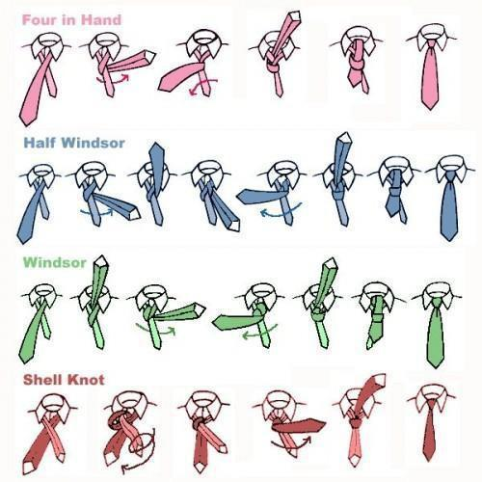

## Attachment 4

**CADET EVALUATION REPORT**

**CADET EVALUATION REPORT**

|  |  |  |  |  |
| --- | --- | --- | --- | --- |
| **Performance** | **Excellent** (4) | **Proficient** (3) | **Developing** (2) | **Unsatisfactory** (1) |
| **Courtesies &**  **Attitude** | Never falters from AFJROTC customs and courtesies. | Consistently in line with AFJROTC customs. Few minor exceptions. | Displays effort in some AFJROTC customs, still developing others. | Does not follow AFJROTC customs whatsoever. Lacks effort. |
| **Appearance** | Professional in uniform. Service dress is in perfect accordance with Air Force Dress and Appearance. | Professionalism could be polished.  Service dress is in regulation with minor discrepancies. | Appears to be improper or disheveled.  Cadet is seeking help to improve uniform dress. | Cadet does not wear uniform according to regulation or often fails to appear in uniform. |
| **Teamwork** | Motivates peers at all times. Performs all tasks with team. Engaged and participates with full effort. | Motivates peers. Gives effort and participates but could display more effort. | Motivates peers sometimes. Attempts to work with fellow cadets, is still till trying. | Does not motivate fellow cadets. Partially involved in the team task but is not engaged. |
| **Communication**  **Skills & Initiative** | Effectively communicates and responds to others. Takes initiative and follows the chain of command before executing an idea. | Communicates well and tries best to respond to others. Takes initiative but occasionally fails to follow the chain of command | Communicates but not to full potential. Rarely has input or takes initiative. Often skips the chain of command. | Does not communicate well or accurately respond to others.  Does not take initiative, never follows the chain of command. |
| **Compliance** | Respectfully complies with orders from authority. | Respectfully complies to orders. Rarely needs reminders. | Complies to orders but frequently defies directions. | Disrespects authority. Constantly defies orders. |

***/20***

|  |
| --- |
| **Additional Remarks:** |

**Attachment 5**

**GRADING RUBRICS**

**5A:: INDIVIDUAL DRILL GRADING**

|  |  |  |  |  |
| --- | --- | --- | --- | --- |
|  | 4 | 3 | 2 | 1 |
| Accuracy | Cadet accurately performs each movement with little to no correction. | Cadet performs each movement with a few corrections. | Cadet performs each movement with many corrections. | Cadet does not perform the movement properly or does not perform it at all |
| Participation | Cadet is actively prepared for drill with proper shoe wear and is participative. | Cadet is mostly prepared for drill with proper shoe wear but may cause a few problems to the ranking cadet. | Cadet is occasionally prepared for drill and does not listen to ranking cadet/causes several problems. | Cadet is not prepared for drill and does not listen to ranking cadet/causes problems. |
| Knowledge of Movements | Cadet fully understands the concept of each movement. | Cadet has some difficulty understanding the concepts of each movement. | Cadet struggles to understand the concepts of each movement. | Cadet does not understand the concepts at all. |

**5B: 30 STEP GRADING SHEET**

**CADET:_______________ ____________ FLT:_______ DATE: __________**

|  |  |
| --- | --- |
| **1. FALL IN** | **16. TO THE REAR MARCH** |
| **2. OPEN RANKS MARCH** | **17. TO THE REACH MARCH** |
| **3. READY FRONT** | **18. COLUMN RIGHT MARCH** |
| **4. CLOSE RANKS MARCH** | **19. FORWARD MARCH** |
| **5. PRESENT ARMS** | **20. EYES RIGHT** |
| **6. ORDER ARMS** | **21. READY FRONT** |
| **7. PARADE REST** | **22. COLUMN RIGHT MARCH** |
| **8. ATTENTION** | **23. FORWARD MARCH** |
| **9. LEFT FACE** | **24. CHANGE STEP MARCH** |
| **10. ABOUT FACE** | **25. COLUMN RIGHT MARCH** |
| **11. FORWARD MARCH** | **26. FORWARD MARCH** |
| **12. RIGHT FLANK MARCH** | **27. FLIGHT HALT** |
| **13. LEFT FLANK MARCH** | **28. LEFT FACE** |
| **14. COLUMN RIGHT MARCH** | **29. RIGHT STEP MARCH** |
| **15. FORWARD MARCH** | **30 FLIGHT HALT** |

1. CONFIDENCE (POSTURE) 0 – 10 ____________

2. MILITARY BEARING (LOST COMPOSURE ETC.) 0 – 10 ____________

3. TIMING/CONTINUITY (PRECISION) 0 – 10 ____________

4. MARCHING DISCIPLINE (SNAP) 0 – 20 ____________

6. CADENCE (IN STEP) 0 – 10 ____________

7. OVERALL IMPRESSION 0 – 10 ____________

8. EXECUTION OF COMMANDS 0 – 30 ____________

**TOTAL** ____________

**5C: PREPAREDNESS AND PREPARATION RUBRIC**

|  |  |  |  |  |
| --- | --- | --- | --- | --- |
|  | 4 POINTS | 3 POINTS | 2 POINTS | 1 POINT |
|  |  |  |  |  |
| **Subject Matter** | Actively discusses | Actively discusses | Occasionally | Hardly ever |
| **Participation** | subject matter every | subject matter most | discusses subject | discusses subject |
|  | day | days | matter | matter |
|  |  |  |  |  |
| **Preparedness** | Brings material | Brings needed material | Occasionally | Seldom brings |
|  | ready to work | and ready to work | brings needed | needed material |
|  | every day | most days | material |  |
|  |  |  |  |  |
| **Attitude** | Positive and trying to | Good attitude most of | Occasionally | Negative attitude |
|  | learn | the time | negative attitude | most of the time |
|  |  |  |  |  |
| **Respect for** | Professionalism at its | Professionalism | Professionalism | Disrespectful, sarcasm, |
| **Others** | best | could be polished | needs work | or belittling fellow students |
|  |  |  |  | or instructor |
|  |  |  |  |  |
| **Attendance** | No lates, 1-2 absences, | Late 1-2, Absent 3-4 | Late 3-4, Absent 3-4 | Late >4, Absent>4 |
|  | no cuts | No cuts | Cut 1 | Cut >1 |
|  |  |  |  |  |

**5D: PHYSICAL TRAINING RUBRIC**

Physical training is an important part of the curriculum. It is important that we all **have a whole person approach to health and physical activity is just one part of that**. Participation and changing are an important part of your grade and we have kept the grading criteria simple for our wellness days; which will be on Fridays. Below is how you will be graded for wellness. **If you do not have sneakers you will not be able to participate and will receive a zero. Also, if you do not change you will receive a zero.**

**Grading Criteria:**

**100 - Prepared and participates (changed into issued or school PT gear and sneakers)**

**75 - Changed but partially prepared (not wearing all issued items) but has sneakers & can participate. Cadets will not get a partial grade if they do not change out from the clothes they wore to school.**

**50 - Changes but does not participate**

**0 - Does not change or participates**

**Safety/waiver process:**

**All students will have to get parental permission to participate via WINGS database generated permission slips/forms**. AFJROTC instructors will ensure that only student’s granted permission and those without medical limitations participate in wellness activities. **Failure to return the permission form by the due date will result in cadets receiving a grade of zero for non-return of form and subsequent zeros for Wellness activities (i.e. wellness days after the due date) until the form is returned. If the cadet does not wear official PT Gear he/she will receive a partial grade of 75 for that Wellness session. Non-participation without a proper excuse (Dr. or parental note) is a zero.**

**Recurrence/location:**

As previously mentioned, Wellness will take place at a time directed by the instructors and in an area of the school designated for such activity (i.e. outdoor sports areas or the wrestling room/gym during inclement weather after coordination with the physical education instructor).

**Athletic attire**:

* Everyone without a medical or other excuse is expected to be dressed for physical education.
* **NOTE**: Official WELLNESS gear will be issued to all cadets.WELLNESS gear or the school's **complete** gym uniform must be worn on WELLNESS days or you will receive partial credit for the day.
* Socks will be black or white which can include a small logo. Cold weather undergarments (ie. tights, spandex, lycra) can be worn outside. There is no restriction on the color of the undergarments.

**Medical excuses**

* A note from a parent/guardian to be excused for the day may be honored by the instructor. If a parental note is consistently presented over the course of an extended period instead of a doctor’s note the SASI may call home to discuss the situation with the parent.
* No one will be excused from participation without the permission of either the AFJROTC instructor and doctor/or the school nurse.
* Extended illness must be acknowledged by written notice from a doctor and presented to the school nurse and the AFJROTC instructor. You will only be excused for the time designated by the attending physician. **If you are exempt from Wellness for an extended time, you will be asked to help out during the class in various ways (this applies after the first excuse). This will afford you the opportunity to get a participation grade instead of just an excuse.**

**Attachment 6**

**Daily Class Statements**

**Mission Statement**

**“To develop citizens of character, dedicated to serving their nation and community”**

**Cadet Honor Code**

**“I will not lie, cheat, or steal nor, will I tolerate anyone among us who does”**

**Air Force Core Values**

**“Integrity First Service Before Self**

**Excellence in All That We Do”**

## Attachment 7

**Cadet Level Chain of Command**

[**Organization/Chain Of Command Chart AY24**](https://docs.google.com/document/u/0/d/1o9pJrJrolgZikjAz5pA9G3wAbY71YzR_k_uyoj5U8D4/edit)

**Attachment 8**

**Cadet Contract and Application**

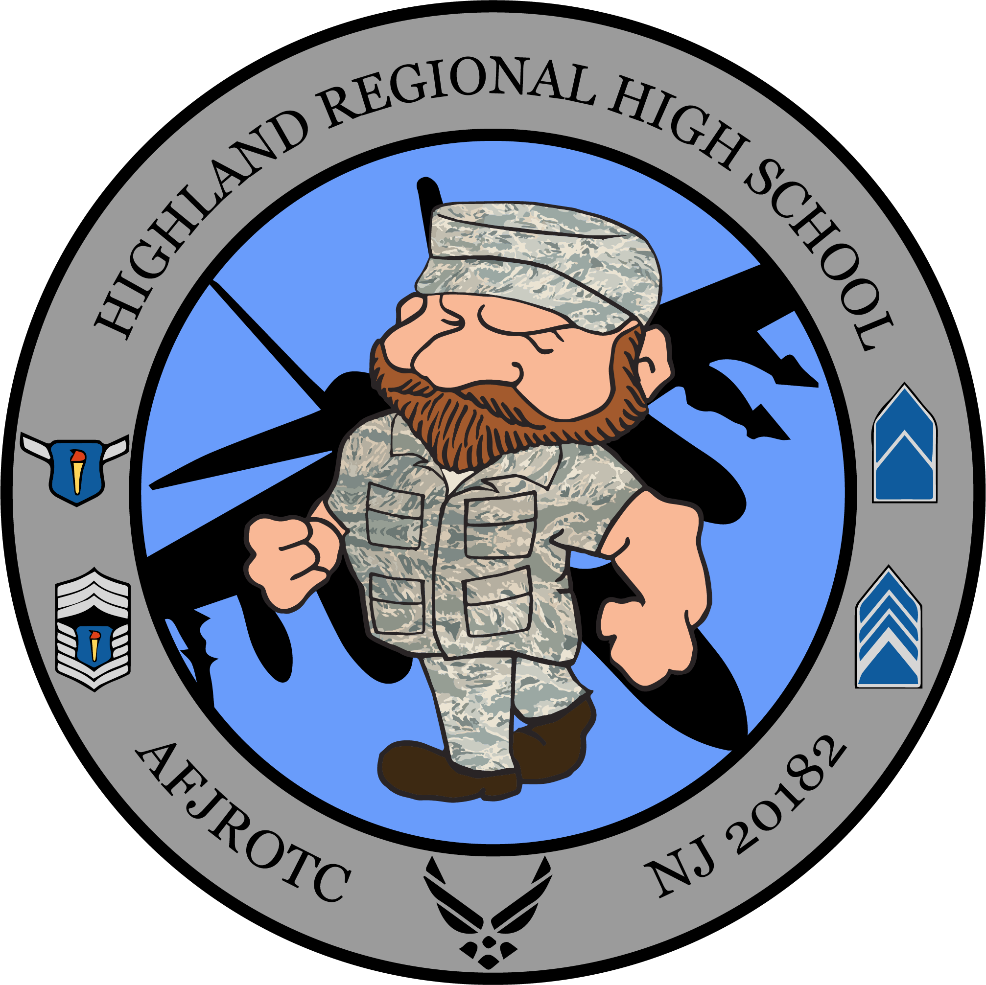

**UNIT NJ 20182**

**AFJROTC CADET CONTRACT**

**APPLICATION AND AGREEMENT FORM:**

**(This document will be uploaded to Google Classroom as a Digital Google Doc)**

***PARENTS AND CADETS MUST SIGN AND SUBMIT THE CADET CONTRACT TO THE UNIT BY THE 15TH OF SEPT 2023. TURN IN WILL BE A HOMEWORK GRADE!!!!***

**______________________________________________________________**

**(Last Name, First Name, Middle Initial) (Flight)**

1. **APPLICATION:** I, the above named cadet, hereby apply for enrollment in the NJ-20182 Air Force JROTC Program
2. **UNDERSTANDING:** Belonging to the cadet corps is a privilege and not a right. The staff reserves the right to remove anyone from the program if they are not meeting the minimum standards spelled out in this contract and the cadet guide..
3. **OBLIGATIONS AND CONSIDERATIONS:** Participation in AFJROTC does not commit or obligate any student to military service. It does not guarantee special consideration if a student chooses to enter any service. However, a cadet who completes two or more years of AFJROTC may qualify for advanced rank and income upon enlistment in the military. Additionally, students who complete two years of AFJROTC and are enrolled in their senior year are eligible to compete for ROTC college scholarships and preferential selection for a United States Service Academy.
4. **AGREEMENT: (Aerospace Science Instructors)** Upon acceptance of this application and the fulfillment of the conditions on the part of the cadet, the Senior Aerospace Science Instructor (SASI) and the Aerospace Science Instructor (ASI) agree to:.(1) Help develop informed citizens. (2) Strengthen and develop character. (3) Help students understand their roles in a democratic republic. (4) Instruct the students about the aerospace age. (5) Familiarize the students with the Air Force and the scholarship and career opportunities that it offers to qualified graduates.
5. **AGREEMENT: (Cadet)** In order to maintain the high standards of courtesy, personal conduct, and appearance required by the Air Force and NJ-20182 as a cadet, I understand and agree to:
6. Meet the standards of behavior, attitude, and courtesy established and taught by the Instructors. I understand and agree that indifference to training or discipline problems such as dishonesty, failure to follow the directions of those in authority, initiating a fight, or suspension from school for misbehavior may result in non-selection for future enrollment in AFJROTC in future semesters, and if significant enough immediate removal.
7. I will wear the regulation Air Force JROTC uniform on those occasions prescribed by the SASI. Refusal to wear the uniform weekly or improper use of the uniform will result in my removal from AFJROTC. Uniform Day is normally every Wednesday
8. I will maintain the uniform in a clean, properly fitted, and repaired manner. I will turn in the complete uniform upon demand. I am responsible for the cost of cleaning and loss, theft, or damage of uniform items. I will meet and maintain the personal grooming standards established by the Air Force. I will take particular attention to **military haircut standards, facial hair, body piercing, tattoos, and body jewelry,** as described in AFJROTC 36-2001
9. I **will complete a minimum of 6 community service hours annually.** Most, if not all of theses hours, will be acquired during the school year within the school
10. I understand that AFJROTC is a place of “sanctuary”. We take care of one another. I understand that disrespect and “bullying” is not tolerated in the corps. Further, inappropriate comments or pictures on social media (Facebook, Snapchat, Instagram, etc.) are not allowed and will result in disciplinary action.
11. I will not engage in any acts of fraternization or Public Display of Affection (PDA). Fraternization essentially is an inappropriate relationship with the opposite gender or use of friendship to bypass rules and discipline within the chain of command. PDA by cadets on campus or AFJROTC or school sponsored activities is expressly forbidden.
12. I will maintain an acceptable standard of academic performance in all classes. I will complete all assignments given to me by my instructor and other teachers. I will be active in class and In co-curricular (also called extra curricular) activities of AFJROTC. Cadets should participate in as many of these activities as possible. (Service Award credit is earned this way). At the end of the year the SASI will review each cadet's academic and behavioral records to determine continuation in the program. I understand that a failing grade in AFJROTC will result in my not being allowed to re-enroll in AFJROTC .
13. I will respond positively to other cadets who have been appointed to leadership positions in the Unit. Rendering proper military courtesies to instructors and other cadets with senior rank is a necessity. I will express courtesy and respect to administrators, teachers, coaches, and other adults with whom I come into contact. I will conduct myself properly when I am entrusted with a position of leadership.
14. I will meet the objectives of the Cadet Corps which are to: (1) Encourage a high degree of personal honor, self reliance, and leadership, (2) promote patriotism, (3) Develop habits of orderliness and precision, (4) Develop a respect constituted authority, and (5) Develop the ability to perform basic military skills associated with drill.
15. I will strive to develop self-discipline and accept personal responsibility for my actions.
16. I will take proper care of materials provided by the Air Force and return them upon request. I will make payment to the AFJROTC office for any books damaged or lost
17. I have read, understand, and **will comply**  with the requirements and information provided to me .

**6. PARENTAl / GUARDIAN APPROVAL:** I hereby give my permission for my daughter/son to participate in the AFJROTC Program. We are responsible for payment of the uniform replacement fees if the uniform and/or uniform items are lost or stolen. My child has read this contract, with particular attention to paragraph Five (5) , and understands the requirements of this program. I understand there is no commitment for military service associated with participation in AFJROTC. I will help my daughter/son maintain the high standards expected of an AFJROTC cadet in NJ-20182 and am **aware he/she can be removed for failure to uphold the standards set forth in this guide and said removal can result in loss of the 5 elective credits.**

***CADET NAME (PRINT): ________________________________________***

***FLT:*** ***_______***

***CADET SIGNATURE: __________________________________________***

***DATE:_________***

***PARENT’S NAME (PRINT):* _____________________________________**

***PARENT’S SIGNATURE*: _______________________________________**

***DATE*:__________**

**PARENT’S EMAIL:_________________________________________**

**Phone: ___________________________________________________**

**Attachment 9**

ADDED INFORMATION FOR PROMOTION TESTS/ INSPECTION QUESTIONS

Along with all the previous information mentioned in this guide, the following items may appear on your promotion tests. Some items will be in textbooks that you may have already turned in. In that case **you will be allowed to sign out the applicable book (i.e. LE 100, or drill manual) before you test and return it before taking the promotion test**.

**Keep in mind that most of the information below will be found in the LE and Drill and ceremonies textbooks**.

1. National Chain of Command (Fill in the names below):

President:_____________________________________

Vice President: ____________________________________

Secretary of Defense: _____________________________________

Secretary of the Air Force: _____________________________________

Chairman Joint Chiefs: _____________________________________

AF Chief of Staff: _____________________________________

CMSgt of Air Force: _____________________________________

2. History of the star spangled banner (i.e. who wrote it and when).

1. Who was the first Chief Master Sergeant of the USAF (LE Book Ch1, L2)?
2. Process of presidential succession (online or reference chapter 6 in the LE 100 text).
3. Execution of proper drill movements and reporting procedures (blue drill and ceremonies manual and LE 100 text). Movements such as Present arms, right and left face, open ranks/close ranks march and column right march.
4. Rules for displaying the US flag and those of other countries or organizations such as the United Nations (reference chapter 6, lesson 1 in LE 100).
5. Founder of Junior ROTC (JROTC), key moments in JROTC history such as when it was founded etc. (chapter 1, LE 100).
6. Award information such as the **highest AFJROTC award** you can receive. Answers to this can be found in LE 100 chapter 1, lesson 2.
7. Customs and courtesies such as when to salute, whom to salute and how to report to an officer when summoned (reference chapter 1, lesson 3)

10. **Additional Information**:

**Unit Chain of Command** (Fill in the names below):

Group CC:___________________________________

Group CV:___________________________________

Command Chief:______________________________

Dir Personnel:________________________________

Dir Logistics:_________________________________

Dir PA:______________________________________

Dir Wellness:________________________________

Dir Finance:__________________________________

Dir Special Projects: ___________________________

Dir Armory:___________________________________

Your Flt CC:__________________________________

Your Flt Sgt:__________________________________

**Air Force JROTC Mission**: “Develop citizens of character dedicated to serving their nation and community.” **(Build Better Citizens for America**).

**Air Force JROTC Goals**: Instill values of citizenship, service to the United States, personal responsibility/sense of accomplishment.

**Honor Code**: “I will not lie, cheat, or steal nor tolerate those among us who do.”

**The Phonetic Alphabet**: Alpha, Bravo, Charlie, Delta, Echo, Foxtrot, Golf, Hotel, India, Juliet ,Kilo, Lima, Mike, November, Oscar, Papa, Quebec, Romeo, Sierra, Tango, Uniform, Victor, Whiskey, X-ray, Yankee, Zulu.

**Time in the Air Force**: Expressed using the 24-hour clock. Noon is 1200 Hours, 6 P.M. is 1800 Hours and Midnight is 2400 Hours. All flyers use Greenwich Mean Time, (or Universal Coordinated Time, Zulu Time), in the air. GMT, or Zulu time, is PST+8 hours or PDT+7 hours.

When saying Zulu time, use date and time. For example, 3:00pm is 1500 hrs is 27/2300 hrs Zulu.

**Common Commands**: Attention (Ten-hut): Stand erect facing forward, Parade Rest: Stand feet apart hands crossed on back, At Ease: Be quiet or relax, Rest: Relax and talk, Fall Out: Depart premises, Fall In: Form up at designated location, Open Ranks: Open for inspection, dress-right-dress, Ready Front: Arm to side, face forward, Dress-Right-Dress: Left arm out head right, Close Ranks: Close formation, Right/Left Face: Turn in place 90 degrees, About Face: Turn 180 degrees to right, Left/Right Step: Move sideways 20”, Forward March (Harch): Left step forward 30”, Halt: Stop, Right/Left Flank: All turn at once 90 degrees, Left/Right Oblique: All turn 45 degrees, Present Arms: Hold salute, Order Arms: Arm to side, Front and Center: Leave ranks, come forward, report, Return to Ranks: Return to ranks, Dismissed: Free to go.

**Folding Flag**: Hold flat with union to left, fold together lengthwise with 1” blue overlap, fold again evenly, triangle fold starting with red/white end. Fold so the flag is all blue w/ stars, tuck in end, carry with hands over chest, and flag tip pointing up.

**Attachment 10**

HIGHLAND REGIONAL HIGH SCHOOL

AFJROTC SYLLABUS

(2023-2024)

**COURSE NAME**: Aerospace Science (AS100-400)

**CREDIT HOURS**: 5 elective credits

**INSTRUCTORS**: ROBERT SIMPSON, Maj, USAF (Retired)

RONALD MAHONEY, CMSgt, USAF (Retired)

**COURSE DESCRIPTION**: AFJROTC is a four-year program offered to high school students in grades 9 – 12. The curriculum includes Aerospace Science (AS), Leadership Education (LE) and Wellness components. All students will be granted academic credit applicable towards the graduation requirement for the successful completion of the AFJROTC course. THERE IS **ABSOLUTELY NO MILITARY OBLIGATION** ASSOCIATED WITH TAKING HIGH SCHOOL AIR FORCE JUNIOR ROTC. Depending on the level (AS100-400), you will Learn how weather affects our lives, learn how to select a career, how to receive training in the selected career field, how to get into and finance a college education, and how to manage your finances. Improve your leadership skills through the study and practice of the concepts of discipline, respect, responsibility and teamwork. Learn the concepts of orderliness and precision through drill and ceremonies. Become better informed citizens. Understand the role of the military in American society

**COURSE OBJECTIVE**: The objectives of AFJROTC are to educate and train high school cadets in citizenship, promote community service, instill responsibility, character and self-discipline and provide instruction in air and space fundamentals.

**REQUIRED TEXT**: There are a myriad of text and workbooks that the cadets will use. Cadets will utilize the books below that apply to the level (LE/AS100-400) in which they are enrolled in. The main textbooks are listed below.

**Aerospace Science**

∙ AS 100: A Journey Into Aviation History

∙ AS 200: The Science of Flight: A Gateway to New Horizons

∙ AS 220: Cultural Studies: An Introduction to Global Awareness

∙ AS 300: Exploring Space: The High Frontier

∙ AS 400: Management of the Cadet Corps

∙ AS 410: Survival: Survive • Return

∙ AS 500: Aviation Honors Ground School

∙ AS 510: AFJROTC Honors Senior Project

∙ AS STEM 1: Unmanned Aerial Vehicles (UAVs)/Quadcopters

**Leadership Education**

∙ LE 100: Traditions, Wellness, and Foundations of Citizenship

∙ LE 200: Communication, Awareness, and Leadership; Second Edition

∙ LE 300: Life Skills and Career Opportunities

∙ LE 400: Principles of Management

**UNIFORM DAY/ WEAR**: Cadets will be issued an Air Force uniform free of charge. If a cadet does not have the appropriate size in inventory, uniforms will be ordered in October with an expected late November or early December delivery. Once cadets get uniforms properly tailored to fit they will have to **wear the uniform on Wednesdays for the entire day**. Uniform wear on the 1st Wednesday of the month will be an alternative assessment that counts towards a student’s grade. Failure to wear the uniform for the entire day, without prior coordination, will result in a 10-point deduction for each period out of uniform; subsequent to and including the discovery of said fact. **All cadets must change back into their uniform after gym. The only exception to this rule is last period gym**.

**WELLNESS DAY**: This would usually occur on **alternate Fridays** and all classes that meet that day will participate in Wellness. This is a gradeand information is provided in your cadet guide. **GRADING PROCEDURES**: The following items will be utilized to come up with a final grade:

- Tests and quizzes

- Homework assignments – **correctable in class to 100%. Grade based on**

**completion percentage. Instructor will collect homework to see who has**

**completed the assignment then had back and go over answers in class.**

**- Notes check**

- Class participation and alternative assessments (i.e. uniform wear, Wellness etc.)

- Extra credit (on tests and quizzes).

- **UNIFORM TURN IN BY SENIORS OR SIZING SHEET VERIFIED FOR RETURNING CADETS**

* **Failure to turn in or verify uniform items by the end of the year or will result in no grades issued and an incomplete for the year.**

**COURSE EVALUATION (Six graded areas within the curriculum)**

* **Uniform Inspection** - Every Wednesday (**30% of grade**)
* **Assessments** – at least 2 per marking period worth 100 points each (**25% of grade**)
* **Homework/Participation/Notes** – weighted at 100 points (**15% each of grade**)
* **Cadet Behavior** - Cadets will be assessed on behavior weekly. (**20% of grade**)
* **Wellness/PT** - Weekly Physical Fitness grade (if a class meets on Friday **(10% of grade)**
* **Final Community Service Assessment** – There will be a final assessment based on your community service hours and a short essay. **Each cadet is expected to have a minimum of 8 hours of community service for the year. The percentage of community service completed along with the essay will be this final assessment test grade.**

**GRADING SYSTEM** (Per Highland Regional High School policy handbook)

93 – 100 = A

90 – 92 = A-

87 – 89 = B+

80 – 82 = B-

83 – 86 = B

77 – 79 = C+

73 – 76 = C-

70 – 72 = C

67 – 69 = D+

65 – 66 = D

Below 65 = F

Information in **this syllabus supersedes any similar or related information found in the student handbook**. This syllabus should be considered an addendum to the student handbook. If there are any questions, please see any one of the two instructors.

**CLASSROOM RULES**

1. **DO NOT be late for class**
2. **DO NOT wear hats in the classroom**
3. **DO NOT chew gum in the classroom**
4. **DO NOT enter the instructor’s office without knocking and receiving permission**
5. **DO NOT sit in the ASI’s chair**
6. **DO NOT sit in the Commander’s chair**
7. **DO NOT place book bags on top of the desk**

**8. DO NOT touch another cadet without permission**

**9. DO NOT WEAR CLOTHES INAPPROPRIATELY (sagging pants, ripped pants etc.)**

**10. DO bring books and cadet guide to class**

**11. DO bring a pencil and pen to class (blue or black ink)**

**12. DO wear your uniform when required**

**13. DO turn in your homework on time**

**14. DO come to class prepared to participate**

**15. DO respond with Sir or Ma’am or their rank when talking to staff cadets and instructors**

**MOTIVATION**

* Success starts with the individual (self-motivate)
* Ask questions. There is no such thing as a dumb question. The only dumb thing is acting like you know something and making a mistake later that could hurt you (academically or physically)
* We determine who we become through our actions and treatment of others
* Respect is earned not automatically given
* Work up to your potential. **DON’T SETTLE FOR JUST GETTING BY!!!**
* We are a team and your support network uses us and others such as your guidance counselors as resources that will help you succeed.
* **Finally, have fun getting to know the other cadets and keep your grades up so you can all participate in the interesting activities we have planned.**

**SEVEN YEAR ACADEMIC SCHEDULE**

**NOTE:** You will be given a separate academic schedule/syllabus on the first or second week of school. This schedule will be flexible and may change due to snow days, class interruptions due to fire drills, building evacuations or guest speakers, short lessons and other events. Extra drill time or discussion topics may be used (i.e. drilling on Tuesdays) to keep on track with the syllabus if we finish a lesson well in advance of the planned time.

|  |  |  |  |  |  |
| --- | --- | --- | --- | --- | --- |
| **CURRICULUM PLAN FOR NJ-20182 (BLENDED/TRADITIONAL) Updated Aug 2023** | | | | | |
| **CADET YEAR** | **2018/2019** | **2019/2020**  **Note(1)** | **2020/2021** | **2021/2022** | **2022/2023** |
| 1 | AS-100  Chapters  1 to 8 | AS-200  Chapters  1-4 | AS-300 | Cult Studies | AS-100 |
| LE-100 + Drill + Unlocking Your Potential  Chapters  1 to 5 | LE-200 + Drill + Unlocking Your Potential  Chapters  1-8 | LE-300 + Drill + Unlocking Your Potential  LE 300 Ch 1, L1-3 | LE-100 (chpts not done in first year) + Drill + Unlocking Your Potential | LE-100 (first yr) + Drill + Unlocking Your Potential |
| 2 |  | AS-200 | AS-300 | AS-100 | AS-100 |
|  | LE-200 + Drill + Unlocking Your Potential | LE-300 + Drill + Unlocking Your Potential | LE-100 + Drill + Unlocking Your Potential | LE-100 (first yr) + Drill + Unlocking Your Potential |
| 3 |  |  | AS-300 | AS-100 | AS-100 |
|  |  | LE-300 + Drill + Unlocking Your Potential | LE-100 + Drill + Unlocking Your Potential | LE-100 (first yr) + Drill + Unlocking Your Potential |
| 4 |  |  |  | AS-400 Corps Mgmt | AS-400 Corps Mgmt |
|  |  |  |  | LE-400 FOM+ Drill |

**Continuation of Curriculum Plan**

|  |  |  |  |
| --- | --- | --- | --- |
| **CURRICULUM PLAN FOR NJ-20182 (BLENDED/TRADITIONAL) Updated Aug 2022** | | | |
| **CADET YEAR** | **2023/2024** | **2024/2025** | **2025/2026** |
| 1 | AS-200 | AS-300 | AS-Cultural Studies |
| LE-200 + Drill + Unlocking Your Potential | LE-300 + Drill + Unlocking Your Potential | LE-100 + Drill + Unlocking Your Potential |
| 2 | AS-200 | AS-300 | AS- Cultural Studies |
| LE-200 + Drill  Unlocking  Your  Potential | LE-300 + Drill + Unlocking Your Potential | LE-300 + Drill + Unlocking Your Potential |
| 3 | AS-200 | AS-300 | AS-Cultural Studies |
| LE-200 + Drill + Unlocking Your Potential | LE-300 + Drill Unlocking Your Potential | LE-100 + Drill + Unlocking Your Potential |
| 4 | AS-400 Corps Mgmt | AS-400 Corps Mgmt | AS-400 Corps Mgmt |
| LE-400 + Drill | LE-400 + Drill | LE-400 + Drill |

Each year we will also cover custom and courtesies and uniform wear from LE 100 for new cadets.

**Attachment 11**

**Unit Departure Form**

Below is a form that may be sent home when a cadet is removed by instructors. If cadets want to leave the program they must speak to ASI and SASI beforehand and turn in a letter stating why they are leaving the program and it must be signed by a parent/guardian. Letter must be written to AFJROTC Unit NJ20182, Highland Regional High School, 450 Erial Road, Blackwood NJ 08012

MEMORANDUM FOR THE PARENTS/GUARDIANS OF CADET XXX .

FROM: AFJROTC NJ-20182/ SASI OR ASI

Highland Regional High School

450 Erial Road

Blackwood NJ 08012

SUBJECT: Failure to Maintain Standards or Meet Requirements.

1. Cadets enrolled in the Air Force Junior ROTC Program are required by the Contractual Agreement between Highland Regional High School and the United States Air Force, applicable service directives, and the NJ-20182 AFJROTC Cadet Guide to meet the standards as described in the following paragraphs.

2. Cadet _____________________ has failed to meet the standards indicated below and may be dis-enrolled from the course.

a. - Failure to maintain acceptable standards.

b. - Ineptitude or indifference to training.

c. - Disciplinary reasons.

d. - Failure to remain enrolled in school.

e. - Other reason: .

3. Cadet ________________________________ has failed to wear the uniform ___ times this semester on the dates of ___________________________________. If he/she does not make these up in accordance with our published grading policy, he/she will receive a failing grade in ROTC.

4. If you would like to contact us in this matter, please give Major Simpson or Chief Mahoney a call during school hours at (856) 227-4100 Ex.4017/4019.

Thank you.