**Highland Regional High School**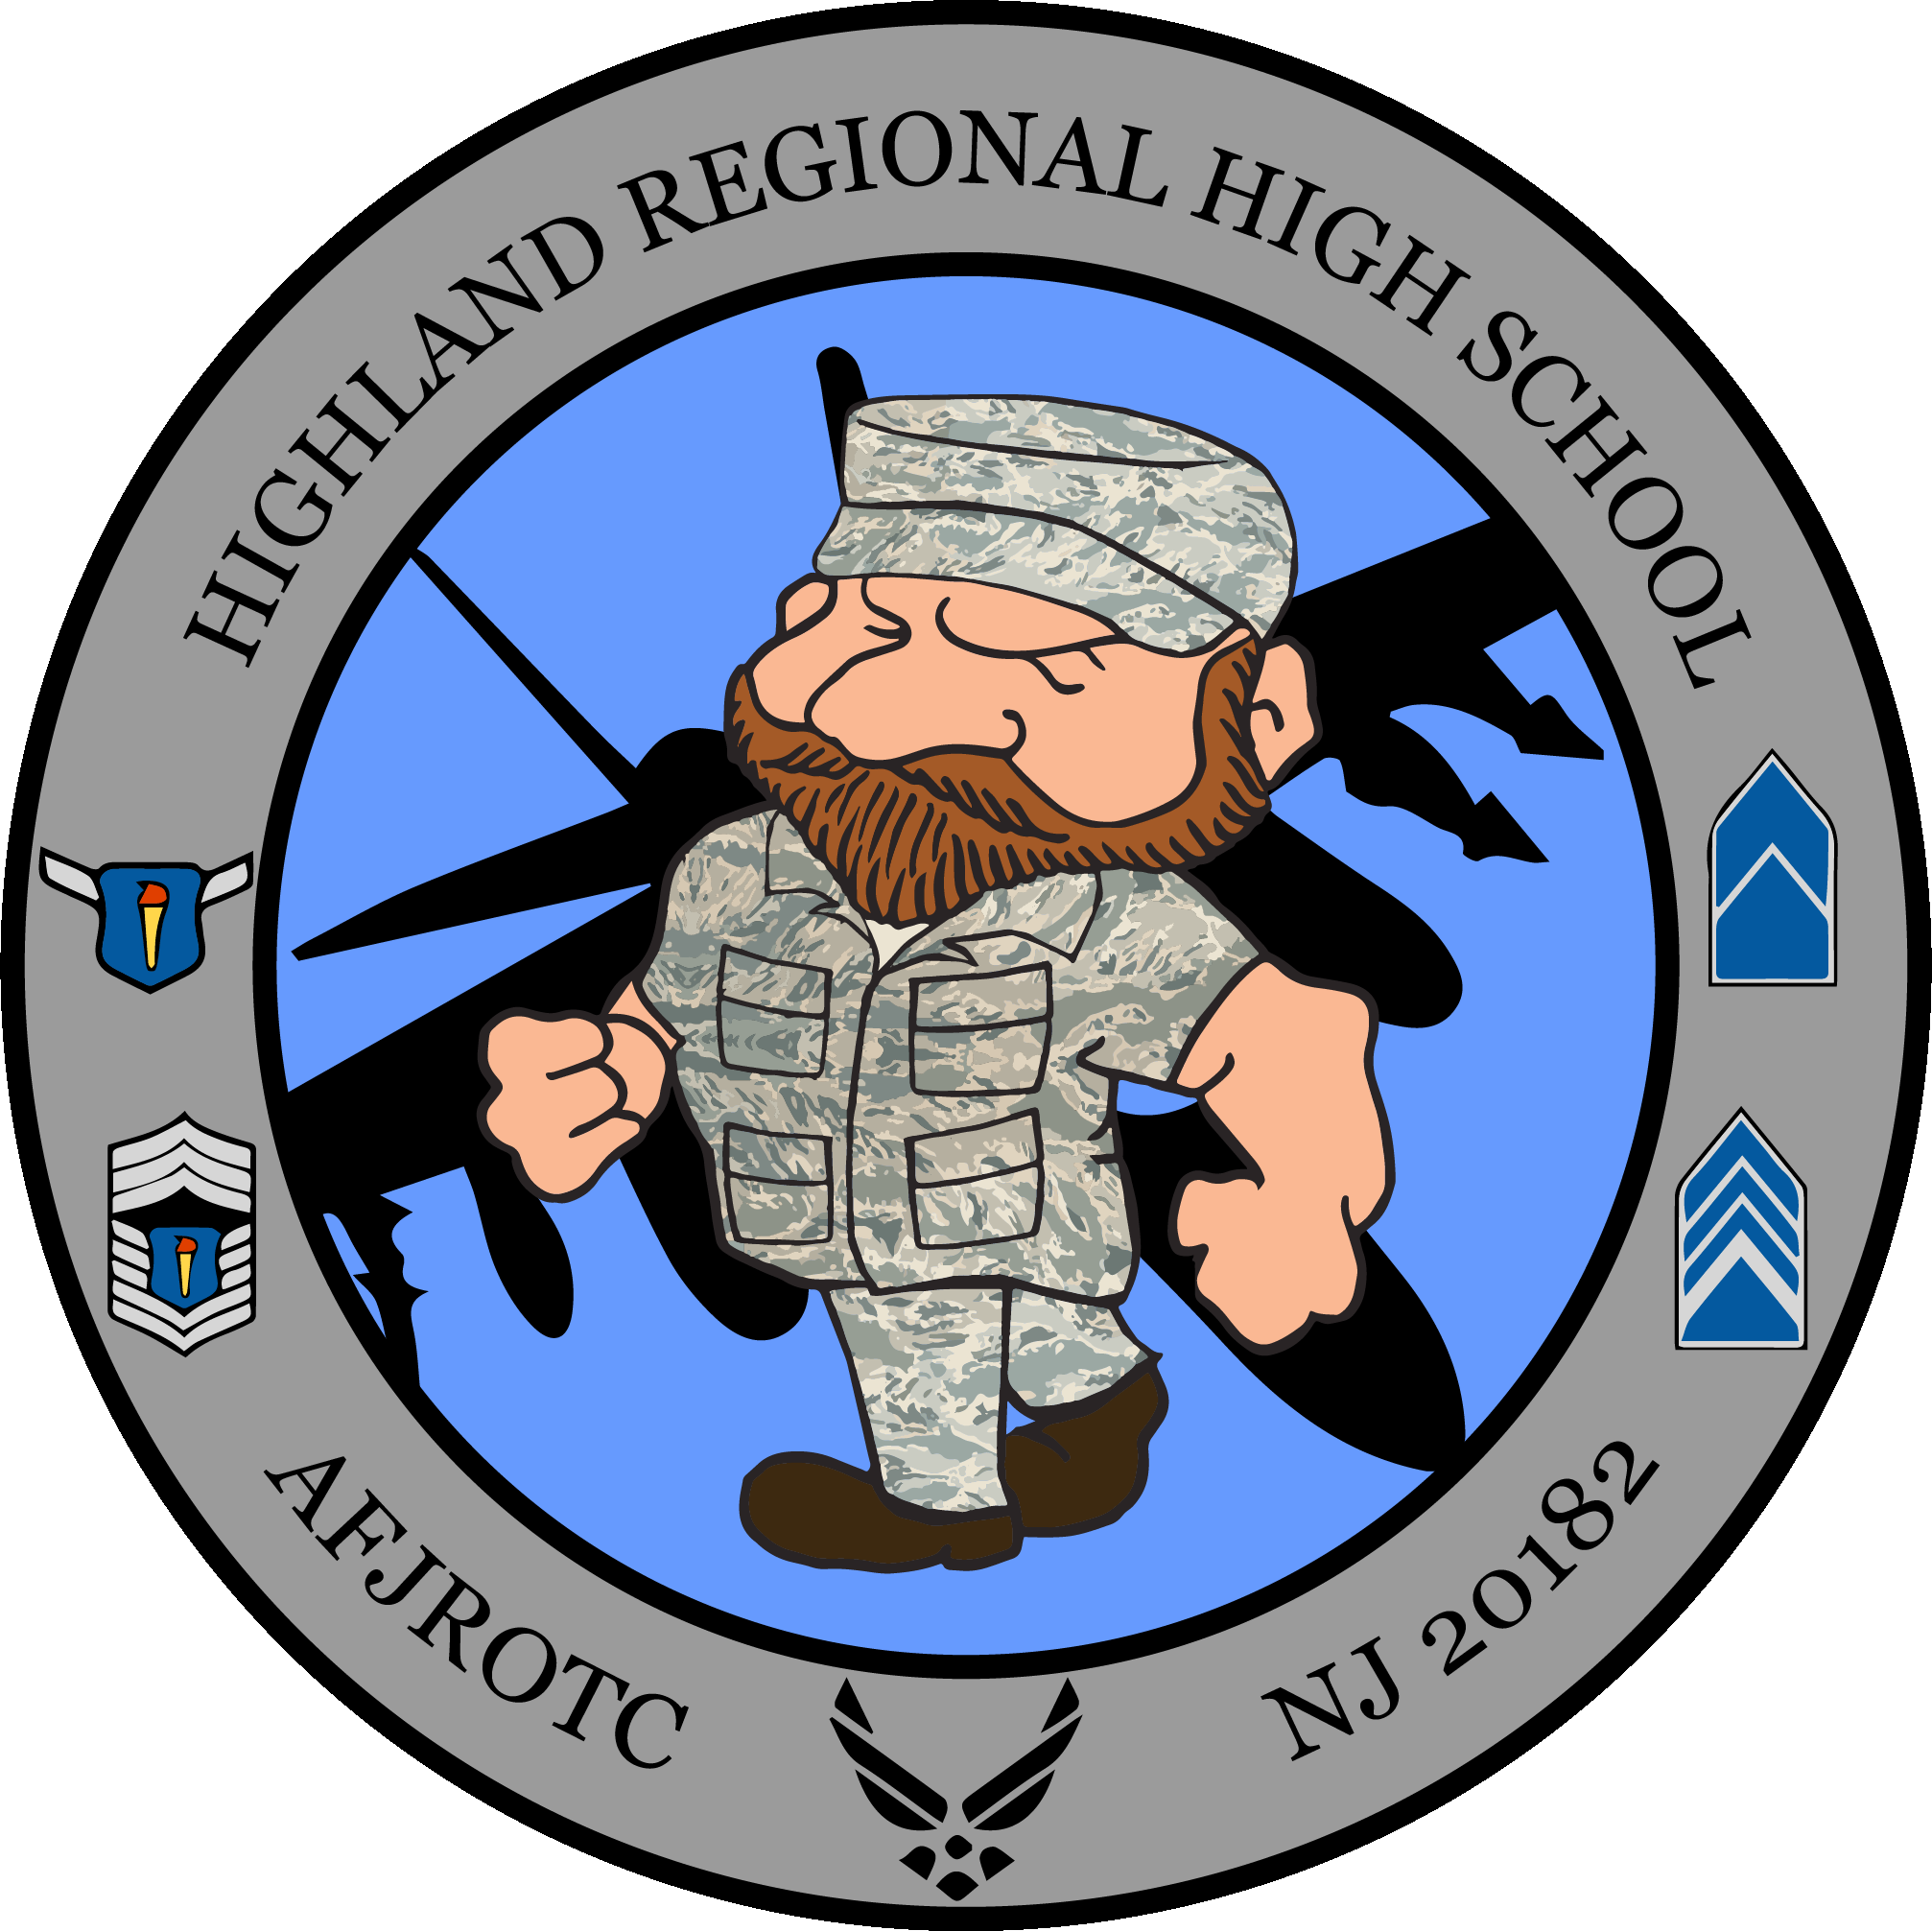

Air Force Junior Reserve Officer Training Corps

(AFJROTC)

Telephone: (856) 227-4100, Ext. 4017/4019

Email: [NJ-20182@afjrotc.net](mailto:NJ-20091@afjrotc.net)

[rsimpson@bhprsd.org](mailto:rsimpson@bhprsd.org) and [rmahoney@bhprsd.org](mailto:rmahoney@bhprsd.org)

**AFJROTC INTAKE/INTERVIEW FORM**

***Please answer the following questions.***

**Name:** __________________________________  **Current School:**______________________

**Current Grade: _____** Eight **____** Freshman **____** Sophomore _**___** Junior **______**Senior ***(please check one)***

| **1.** | How interested are you in taking this class? (Circle one choice) | **Very Interested** | **Somewhat interested** | | **Curious on the subject matter** | | **Not sure** | |
| --- | --- | --- | --- | --- | --- | --- | --- | --- |
| **2.** | Please explain your reason(s) for taking this class? | | | | | | | |
| **3.** | **Are you willing to wear our AFJROTC uniform once per week?** | | | | | **Yes** | | **No** |
| **4.** | **Are you willing to conform to AFJROTC haircut and grooming standards on uniform days and remove any unauthorized/extra piercings during uniform inspection dates and are you willing to wear the uniform the entire day and comply with dress and appearance standards in accordance with AFJROTC rules?** | | | | | **Yes** | | **No** |
| **5.** | Are you choosing this class freely or is someone recommending this course? If taking on a recommendation, who recommended this course? (**place name and relationship below**)  _______________________________________________________________________ | | | | | Yes | | No |
| **6.** | Are you willing to accept the standard of having a minimum of a “C” (76%) average in all your classes? | | | | | Yes | | No |
| **7.** | Are you willing to comply with our physical training (PT) standards by changing and working out once per week with your class? | | | | | Yes | | No |
| **8.** | Have you been suspended more than one time for fighting, disrespect or not complying with a dress code? | | | | | Yes | | No |
| **9.** | Are you willing to **commit to staying with the program for the entire year** with the understanding that once accepted, **dropping the course will not be supported by the instructors and a denial of such a choice will be passed to guidance?** | | | | | Yes | | No |
|  | In this section, please rate the following statements: | **Strongly  agree** | | **Somewhat  agree** | | **Somewhat disagree** | | **Disagree** |
| **10.** | I believe that I can work well with others and help build a positive program | 1 | | 2 | | 3 | | 4 |
| **11.** | I can focus in class and not be a distraction | 1 | | 2 | | 3 | | 4 |
| **12.** | I can follow and comply with a schedule of events such as a syllabus | 1 | | 2 | | 3 | | 4 |
| **13.** | I consider my attendance very good | 1 | | 2 | | 3 | | 4 |

**APPROVED: _____Yes _____ No By:_______________________________ Date: __________**

**ROBERT V. SIMPSON, Maj, USAF(Ret)**, Senior Aerospace Science Instructor, AFJROTC Unit NJ-20182

# AEROSPACE SCIENCE (Air Force Junior ROTC) DEPARTMENT

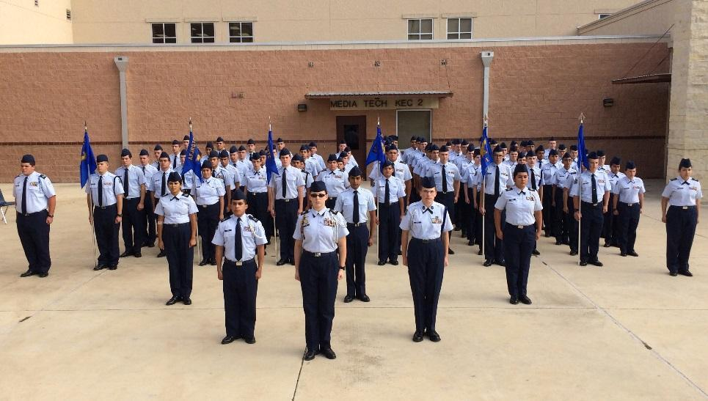

**A. Air Force Junior Reserve Officer Training Corps (AFJROTC)** is a series of three to four five-credit courses offered to all high school students. This course can fulfill either the 21st century skills or Visual Performing Arts requirement for the state of New Jersey.

**B.** Your child has expressed interest in the JROTC program at Highland High School. A request for entry into the program has been put into the system. If accepted into the program, **you have two options to enroll. You can fully transfer to Highland or take a morning wheel option where your morning classes; to include AFJROTC are at Highland and you return by but to your home school to complete your afternoon courses**. There is always the option to fully transfer to Highland if you decide to do so later. Keep in mind that there would be no cost to your or your family, and transportation will be provided. Please sign below and have it returned to your child’s counselor or Major Simpson in order to be considered. If you have any questions, please contact your child’s counselor or Major Simpson at 856-227-4100 Ext: 4017.

I, ________________________________________, give permission for my child to request the JROTC program at Highland. Select home school below. **Select home school below; If Triton or Timber Creek, go to part C, otherwise continue to part D.**



School **SCHEDULED** for next year: Highland Triton Timber Creek

**C.** SCHEDULING OPTIONS

| **TIMBER CREEK OR TRITON STUDENTS ONLY:** CHECK ONE CHOICE BELOW:  ______ **FULL TRANSFER** ________ **MORNING WHEEL OPTION** (HALF DAY)  **I understand that if I transfer fully to Highland and my child is removed or drops the course, they will be transferred back to their home school.** |
| --- |

**D.** Name of the Student **(print)**: _______________________________________________

Your name (Parent or Guardian): _______________________________________________

Your Signature: _________________________________________ Date: ____________

APPROVED: ___Yes ___ No By:_____________________________ Date: __________

**ROBERT V. SIMPSON, Maj, USAF (Ret)**, Senior Aerospace Science Instructor, AFJROTC Unit NJ-20182